

2018 Air Quality Annual Progress Report (APR) for Falkirk Council
In fulfilment of Part IV of the Environment Act 1995

Local Air Quality Management June 2018

Local Authority Officer | John Millar
Department | Environmental Health
Address | Abbotsford House, Davids Loan, Falkirk, FK2 7YZ
Telephone | 01324 504873
E-mail | JohnA.Millar@falkirk.gov.uk
Report Reference number | Annual Progress Report 2018
Date | June 2018

Executive Summary: Air Quality in Our Area

Air Quality in Falkirk Council
The 2017 Falkirk Council air quality monitoring results for all pollutants measured have shown an improvement from the 2016 results through reduced exceedance concentration levels.
Specifically, the Nitrogen Dioxide (NO₂) National Air Quality Standard (NAQS) objectives were achieved at all seven automatic monitoring sites within the Falkirk Council automatic network. The highest annual mean NO₂ concentration of 36µg/m³ was recorded at the Falkirk West Bridge Street site. In 2016 the highest annual mean NO₂ concentration was recorded at the Falkirk West Bridge St site with a level of 37µg/m³.
In 2017, there were no NO₂ diffusion tubes which recorded a concentration greater than the annual NAQS objective of 40µg/m³. This is another significant improvement from 2016 as results at two sites (NA27 Falkirk West Bridge St and NA111 Falkirk West Bridge St Air Quality station) had breached this limit. Long term NO₂ monitoring data also indicates a downward trend in concentrations at both background and roadside sites which is again, regarded as an overall improvement.
Falkirk West Bridge St is located within the Falkirk Town Centre Air Quality Management Area (AQMA) which was declared in 2011 in recognition of the potential to exceed NAQS objectives for NO₂ and Particulate Matter (PM₁₀). The Falkirk Town Centre Air Quality Management Action Plan (AQAP) was approved in June 2015 and focuses on long-term key point actions to reduce air pollution in the area rather than short-term fixes. Key measures outlined in the plan are:
- Reducing emissions from individual vehicles
- Promoting the EcoStars Fleet Recognition Scheme
- Promoting alternative and sustainable modes of transport
- To educate and inform the public on air quality issues
In 2017, Falkirk Council has made significant progress in implementing these measures. For example, there are now 27 electric vehicle (EV) charging bays throughout the Falkirk area with more planned in the upcoming year, an action which

is helping to promote alternative modes of travel and help to achieve measures included in the Sustainable Development and Climate Change Strategy 2012 - 2017.
Plans for future upgrades of the EV charge network include:
- Replacing the 50kW charger at Meeks Road, along with a 22kW charger at Larbert Station;
- A Low Carbon Vehicle Hub at Falkirk Stadium (Plans for approx. 20 vehicle charging bays – 22kW and 50kW) under a photovoltaic canopy.
The Falkirk Council vehicle fleet currently includes twelve electric cars and three electric vans. There are plans to increase this EV fleet in the future.
The Council are also promoting an active travel hub in Falkirk town centre with the Forth Environmental Link looking at introducing a bike hire scheme similar to that in Stirling and Glasgow with an expected implementation date by December 2018. Full details of the progress Falkirk Council are making towards the measures outlined in their Air Quality Action Plans can be seen in Section 2.2 of this report.
In 2017, the six automatic sulphur dioxide (SO₂) analysers within the Falkirk monitoring network met all three (15-minute, hourly and daily) NAQS objectives.
There were exceedances (15min SO₂ Objective: 266µg/m³) recorded at both the Grangemouth Moray site (Annual total: 10) and Grangemouth Municipal Chambers
(4) but these were within the NAQS annual limit. This was proven to be a substantial improvement from 2016 where Grangemouth Moray and Grangemouth Municipal Chambers sites both recorded 28 exceedances (total: 56) of this annual total objective.
The 2017 SO₂ results continue the objective compliance recorded in 2013, 2014 and 2015, and 2016. Long term SO₂ trend analysis at the Grangemouth AURN site shows a decline in SO₂ concentrations since the commissioning of the tail gas treatment (TGT) unit at INEOS Grangemouth in 2013.
Falkirk Council measured PM₁₀ concentrations at eight locations during 2017. The Scottish NAQS objectives for PM₁₀ were met at all eight locations.
The two sites with the highest annual mean PM₁₀ concentration (but within the Scottish NAQS PM₁₀ objective) was: A13–Banknock 2 (Roadside, 13µg/m³) and A15–Main St, Bainsford (Roadside, 13µg/m³).

Over a five year period (from 2013 until 2017), all eight sites have recorded PM₁₀ (annual mean) long term reductions.
The Banknock 2 monitoring site recorded the greatest number of PM₁₀ daily exceedances (7) which was substantial increase from 4 recorded in 2015, this is within the Scottish NAQS limit (>50µg/m³, not to be exceeded more than 7 times per year).
Over a five year period (from 2013 until 2017), three sites have recorded PM₁₀ (24- hour mean) reductions: A4–Falkirk Haggs (Roadside), A7–West Bridge Street, Falkirk (Roadside) and A12–Grahams Road, Falkirk (Roadside). Two sites have recorded increased PM₁₀ (24hr mean) results: A8–Grangemouth AURN (Urban Background/Industrial) and A13–Banknock 2. Two sites has remained at the same PM₁₀ (24hr mean) level: A10-Grangemouth Municipal Chambers and A15-Main St, Bainsford.
The benzene and 1, 3-butadiene diffusion tube monitoring conducted in 2017 met the NAQS (annual running mean) objectives for each pollutant respectively.
During 2017, all three PM_{2.5} automatic sites recorded the same annual mean concentration (within the Scottish NAQS PM_{2.5} objective) of 6µg/m³. Data capture was reasonable for the Falkirk West Bridge St site at 88% and good for the Grangemouth AURN and Banknock 2 sites, these were 95% and 99% respectively.
The PM_{2.5} concentrations recorded at the Grangemouth AURN site have gradually reduced over longer-term from 9.2µg/m3 in 2012 to 6µg/m3 in 2016 and 2017. This reduction may be attributed to the commissioning of the tail gas treatment (TGT) unit at the INEOS Grangemouth complex in 2013. Since the commissioning of the TGT unit, SO₂ concentrations have reduced within the Grangemouth AQMA. Sulphate species are known to contribute towards the formation of secondary PM_{2.5}, a reduction in SO₂ could impact on local PM_{2.5} concentrations.
As no exceedances of NAQS occurred outside existing AQMAs, no new Detailed Assessment of any pollutant is required.

Actions to Improve Air Quality
Falkirk Council made a number of improvements to its air quality monitoring network equipment during 2017. Improvements include upgrading communications throughout the network such as the installation of a new datalogging / comms unit at the Grangemouth AURN site along with a new modem system at the Falkirk West Bridge St site. This allows improved data capture rates, security and connectivity throughout.
It is anticipated that DEFRA will be upgrading the PM₁₀ and PM_{2.5} TEOM analysers within the Grangemouth AURN site in 2018. Beta Attenuation Monitors (BAMS) will be the replacement analyser type. Upgrade information will be provided in the 2019 Annual Progress Report.
In 2017, the membership of Falkirk EcoStars Fleet Recognition scheme now has 160 vehicle operators. This scheme helps to improve air quality through the promotion of fuel efficient driving within the Council area. In addition we are also working closely with fellow members of the East Central Scotland Vehicle Emissions Partnership (ECSVEP), looking to align our vehicle emissions monitoring with the priorities and objectives set out in the Scottish Government’s Cleaner Air for Scotland (CAFS) document. Funding has been provided to continue the operation of the Falkirk EcoStars scheme (Fleet Operators and Taxis) during 2017 / 2018.
Falkirk Council also continues to work closely with its partner organisations to manage local air quality issues. The council works closely with SEPA, INEOS and Petroineos to reduce exceedances of the SO₂ objectives within the Grangemouth AQMA.

Local Priorities and Challenges
Education and Awareness of Air Quality Issues
In 2018, Falkirk Council will be looking to develop our engagement with local schools, through promoting air quality education resources such as the ‘Learn about Air’ teaching package, the Clean Air Day and working closer with the Transport Planning department on how to promote alternative / sustainable local transport solutions.

Grangemouth Industry Modelling Study
The Scottish Government has approved a comprehensive 2018 pollution modelling study and assessment within the Grangemouth AQMA area / Industrial area. This

would help inform future monitoring requirements and management of the Grangemouth AQMA. This will also be beneficial in improved understanding of the current pollution sources / industry and how these will be changing into the future.

Air Quality Station – Proposed Equipment Transfer / Decommissioning

Plans are being drafted for transferring the Falkirk, Grahams Road PM₁₀ TEOM analyser to the nearby Hope St site in order to provide an improved roadside Falkirk town centre monitoring location. This would involve a full decommissioning of the current Grahams Road site thus reducing monitoring stations from twelve to eleven but will maintain the same monitoring capability.

How to Get Involved
To obtain further information on air quality within the Falkirk Council area, please visit our air policy webpage at
http://www.falkirk.gov.uk/services/environment/environmental-policy/air-quality/
There are eleven automatic air quality monitoring sites across the Falkirk Council area. The monitoring data from all of the sites can be viewed on the Scottish Air Quality website at:
http://www.scottishairquality.co.uk/latest/summary?view=la
To learn more about the EcoStars Fleet Recognition Scheme and for details of how to join if you are a commercial fleet operator please visit:
https://www.ecostars-uk.com/eco-stars-schemes/

Table of Contents

Executive Summary: Air Quality in Our Area i
Air Quality in Falkirk Council i
Actions to Improve Air Quality iv
Local Priorities and Challenges iv
How to Get Involved v
- Local Air Quality Management 1
- Actions to Improve Air Quality 2
  - Air Quality Management Areas 2
  - Progress and Impact of Measures to address Air Quality in Falkirk Council Area 3
  - Cleaner Air for Scotland 19
    - Transport – Avoiding travel – T1 19
    - Climate Change – Effective co-ordination of climate change and air quality
policies to deliver co-benefits – CC2 20
- Air Quality Monitoring Data and Comparison with Air Quality
Objectives 21
  - Summary of Monitoring Undertaken 21
    - Automatic Monitoring Sites 21
    - Non-Automatic Monitoring Sites 21
  - Individual pollutants 22
    - Nitrogen Dioxide (NO₂) 22
    - Particulate Matter (PM₁₀) 23
    - Particulate Matter (PM_{2.5}) 24
    - Sulphur Dioxide (SO₂) 26
    - Carbon Monoxide, Lead, 1,3-Butadiene, Benzene 27
- New Local Developments 29
  - Road Traffic Sources 29
    - Narrow Congested Streets 29
  - Other Transport Sources 30
    - Airports 30
  - Industrial Sources 31
  - Commercial and Domestic Sources 32
    - Biomass Combustion Plants 32
  - New Developments with Fugitive or Uncontrolled Sources 34
- Planning Applications 35
- Conclusions and Proposed Actions 37
  - Conclusions from New Monitoring Data 37
  - Conclusions relating to New Local Developments 40
  - Proposed Actions… 44
Appendix A: Monitoring Results 45
Appendix B: Full Monthly Diffusion Tube Results for 2017 96
Appendix C: Supporting Technical Information / Air Quality Monitoring
Data QA/QC 102
Glossary of Terms 113
References 114

List of Tables
Table 1.1 – Summary of Air Quality Objectives in Scotland 1
Table 2.1 – Declared Air Quality Management Areas… 2
Table 2.2 - Electric Vehicle Charging Points at Council Depots / Public Places in Falkirk 5
Table 2.3 – Progress on Measures to Improve Air Quality 7
Table A.1 – Details of Automatic Monitoring Sites… 46
Table A.2 – Details of Non-Automatic Monitoring Sites… 48
Table A.3 – Annual Mean NO₂ Monitoring Results… 53
Table A.4 – 1-Hour Mean NO₂ Monitoring Results… 58
Table A.5 – Annual Mean PM₁₀ Monitoring Results… 65
Table A.6 – 24-Hour Mean PM₁₀ Monitoring Results… 66
Table A.7 – Annual Mean PM_{2.5} Monitoring Results… 72
Table A.8 – SO₂ Monitoring Results… 76
Table A.9 – 1,3 Butadiene Annual Mean Diffusion Tube Results for 2017 87
Table A.10 – Benzene Annual Mean Diffusion Tube Results for 2017 88
Table A.11 – Pumped Benzene Annual Mean Results for 2017 89
Table A.12 – Estimated Annual Mean PM_{2.5} Results 2017 90
Table B.1 – NO₂ Monthly Diffusion Tube Results for 2017 97
Table B.2 – 1,3 Butadiene Monthly Diffusion Tube Results for 2017 101
Table B.3 – Benzene Monthly Diffusion Tube Results for 2017 102
Table C.1 – Comparison of Local vs National Bias Factor Summary 104
Table C.2 – Locally Derived PM_{2.5} / PM₁₀ Correction Ratio 110
Table C.3 – PM₁₀ Short Term to Long Term Adjustment Factor – Banknock 3 110
Table C.4 – Details of the QA/QC at the Automatic Monitoring Stations in 2017 111

List of Figures
Figure 1 – A4 Falkirk Haggs Long Term NO₂ Concentrations… 59
Figure 2 – A5 Falkirk Hope St Long Term NO₂ Concentrations 60
Figure 3 – A7 Falkirk West Bridge St Long Term NO₂ Concentrations… 61
Figure 4 – A8 Grangemouth AURN Long Term NO₂ Concentrations 62
Figure 5 – A9 Grangemouth Moray Long Term NO₂ Concentrations 63
Figure 6 – A9 Grangemouth Municipal Chambers Long Term NO₂ Concentrations. 64
Figure 7 – A4 Falkirk Haggs Long Term PM₁₀ Concentrations… 67
Figure 8 – A7 Falkirk West Bridge St Long Term PM₁₀ Concentrations… 68
Figure 9 – A8 Grangemouth AURN Long Term PM₁₀ Concentrations… 69
Figure 10 – A10 Grangemouth MC Long Term PM₁₀ Concentrations… 70

Figure 11 – A13 Banknock 2 Long Term PM₁₀ Concentrations… 71
Figure 12 – A7 Falkirk West Bridge St Long Term PM_{2.5} Concentrations… 73
Figure 13 – A8 Grangemouth AURN Long Term PM_{2.5} Concentrations… 74
Figure 14 – A13 Banknock 2 Long Term PM_{2.5} Concentrations… 75
Figure 15 – A3 Bo’ness Long Term SO₂ Concentrations… 77
Figure 16 – A8 Falkirk Hope St Long Term SO₂ Concentrations… 78
Figure 17 – A5 Grangemouth AURN Long Term SO₂ Concentrations 79
Figure 18 – A9 Grangemouth Moray Long Term SO₂ Concentrations 80
Figure 19 – A10 Grangemouth MC Long Term SO₂ Concentrations 81
Figure 20 – A11 Grangemouth Zetland Park Long Term SO₂ Concentrations… 82
Figure 21 – Polar Plots of Average SO2 Concentrations in the Grangemouth sites. 83
Figure 22 – Exceedances of the 15-min Air Quality Objective Concentration at the Grangemouth sites 2013 -2017 86
Figure 23 – Maps of the AQMA Boundaries in the Falkirk Council Area 91
Figure 24 – Maps Showing Automatic Monitoring Locations… 93
Figure 25 – NO₂ Locally Derived Bias Adjustment Factor Spreadsheets… 105
Figure 26 – NO2 National Derived Bias Adjustment Factor Spreadsheet 108

Local Air Quality Management
This report provides an overview of air quality in Falkirk Council’s area during 2017. It fulfils the requirements of Local Air Quality Management (LAQM) as set out in Part IV of the Environment Act (1995) and the relevant Policy and Technical Guidance documents.
The LAQM process places an obligation on all local authorities to regularly review and assess air quality in their areas, and to determine whether or not the air quality objectives are likely to be achieved. Where an exceedance is considered likely the local authority must declare an Air Quality Management Area (AQMA) and prepare an Air Quality Action Plan (AQAP) setting out the measures it intends to put in place in pursuit of the objectives. This Annual Progress Report (APR) is summarises the work being undertaken by Falkirk Council to improve air quality and any progress that has been made.
Table 1.1 – Summary of National Air Quality Strategy Objectives in Scotland

Pollutant | Air Quality Objective |  | Date to be achieved by
Pollutant | Concentration | Measured as | Date to be achieved by
Nitrogen dioxide (NO₂) | 200 µg/m³ not to be exceeded more than 18 times a year | 1-hour mean | 31.12.2005
Nitrogen dioxide (NO₂) | 40 µg/m³ | Annual mean | 31.12.2005
Particulate Matter (PM₁₀) | 50 µg/m³, not to be exceeded more than 7 times a year | 24-hour mean | 31.12.2010
Particulate Matter (PM₁₀) | 18 µg/m³ | Annual mean | 31.12.2010
Particulate Matter (PM_{2.5}) | 10 µg/m³ | Annual mean | 31.12.2020
Sulphur dioxide (SO₂) | 350 µg/m³, not to be exceeded more than 24 times a year | 1-hour mean | 31.12.2004
Sulphur dioxide (SO₂) | 125 µg/m³, not to be exceeded more than 3 times a year | 24-hour mean | 31.12.2004
Sulphur dioxide (SO₂) | 266 µg/m³, not to be exceeded more than 35 times a year | 15-minute mean | 31.12.2005
Benzene | 3.25 µg/m³ | Running annual mean | 31.12.2010
1,3 Butadiene | 2.25 µg/m³ | Running annual mean | 31.12.2003
Carbon Monoxide | 10.0 mg/m³ | Running 8-Hour mean | 31.12.2003
Lead | 0.25 µg/m³ | Annual Mean | 31.12.2008

Actions to Improve Air Quality

Air Quality Management Areas
Air Quality Management Areas (AQMAs) are declared when there is an exceedance or likely exceedance of an air quality objective. After declaration, the authority must prepare an Air Quality Action Plan (AQAP) within 12 months, setting out measures it intends to put in place in pursuit of the objectives.
A summary of AQMAs declared by Falkirk Council can be found in Table 2.1
Further information related to declared or revoked AQMAs, including maps of AQMA boundaries are available online at https://uk-air.defra.gov.uk/aqma/local- authorities?la_id=371 – see full list at http://uk-air.defra.gov.uk/aqma/list
Falkirk Council plans to undertake a full assessment of the Grangemouth AQMA during 2018 complimented by an extensive air quality modelling exercise of industrial sources. This will inform future monitoring requirements and management of air quality within this industrial region. The Scottish Government has provided support for this assessment.
A review and assessment is planned to be undertaken on the Banknock AQMA during 2018.
A review and assessment of the Falkirk Town Centre and Haggs AQMAs will be undertaken in 2019.

Table 2.1 – Declared Air Quality Management Areas

AQMA  Name | Pollutants and Air Quality  Objectives | City / Town | Description | Action Plan
Falkirk Town Centre | NO₂ annual mean  PM₁₀ 24-hour mean and annual mean | Falkirk | An area encompassing an area of Falkirk Town Centre. | Air Quality Action Management Plan (Falkirk Town Centre and Haggs) 2015  Air Quality Management Action Plan (Falkirk Town Centre and Haggs)  June 2015
Banknock | PM₁₀ 24-hour mean and annual mean | Banknock | An area encompassing an area within Banknock, Falkirk. | Air Quality Action Management Plan (Banknock)
Haggs | NO₂ annual mean | Haggs | An area that connects Banknock and Haggs around the road junction of the A803 and M80 | Air Quality Management Plan (Falkirk Town Centre and Haggs) 2015  Air Quality Management Action Plan (Falkirk Town Centre and Haggs) June 2015
Grangemouth | SO₂ 15-min mean | Grangemouth | An area encompassing the Grangemouth industry areas, shipping port and adjacent residential areas | Air Quality Management Plan (Grangemouth)  2010  Available on request

Progress and Impact of Measures to Address Air Quality in Falkirk Council Area
Falkirk Council has taken forward a number of measures during the current reporting year of 2017 in pursuit of improving local air quality. Details of all measures completed, in progress or planned are set out in Table 2.3. More detail on these improvement measures can be found in the relevant AQAP relating to each AQMA.

Key completed measures are:
Measure 1: Improving Grangemouth SO₂ Data Access
Falkirk Council regularly sends provisional SO₂ and associated meteorological data to SEPA, INEOS, Petronineos and other interested parties when an SO₂ exceedance is recorded at an air quality monitoring station within the Grangemouth AQMA. In addition a monthly summary is sent and annual running totals are produced.
Measure 3: Text Alert System (Upgrade)
A text alert system had previous been installed in 2013 to provide local contacts (SEPA, INEOS, Petroineos etc.) with air quality information when breaches of NAQS objectives were occurring - this system was linked to individual analysers. A new system will be commissioned in 2018 to work in tandem with the Falkirk Council data collection software and can be used for any pollutant measured (rather than just SO₂). It will also have the functionality of producing email alerts to users in addition to texts.
Measure 5: Electric Vehicles (EV) and Plug-ins
Electric Vehicle charging points at Council depots and points installed at public places throughout the region can be shown in the Table 2.2.

Table 2.2 Electric Vehicle Charging Points at Council Depots / Public Places in Falkirk

Location | Type | Number of Bays | Available to Public
Municipal Buildings West Bridge Street Falkirk  FK1 5RS | 7kW | 4  (Increased from 2 in 2016) | No
Abbotsford House David’s Loan Falkirk  FK2 7YZ | 7kW | 2 | No
Dalgrain Depot McCafferty Way Grangemouth  FK3 8EB | 7kW 50kW | 2  1 | No
Inchyra Depot Inchyra Road Grangemouth  FK3 9XB | 7kW | 4  (Increased from 1 in 2016) | No
Larbert Railway Station Foundry Loan (East) Larbert  FK5 4PJ | 22kW | 2 | Yes
Grahamston Railway Station Meeks Road  Falkirk  FK2 7EZ | 50kW | 2 | Yes
Town House Street Denny  FK6 5DX | 22kW | 2 | Yes
Union Road Car Park Grangemouth  FK3 8AB | 22kW | 2 | Yes
Falkirk Stadium 4 Stadium Way Falkirk  FK2 9EE | 2 x 22kW  1 x 50kW | 4  2 | Yes
There are many EV charge points located at various locations throughout the Falkirk Council area – these can be viewed using the following web link: http://www.chargeyourcar.org.uk/
Progress in 2017 of EV charging infrastructure:
- A new 22kW charger has been installed at Drossie Road (Falkirk High Station) and a 7kW charger installed at Slamannan Road (Falkirk High Station)
- Abellio have installed a 7kW charger in the main Falkirk High Station car park

- Scottish Canals have installed a charger at the Falkirk Wheel Plans for future upgrades of the EV charge network include:
- Replacing the 50kW charger at Meeks Road, along with a 22kW charger at Larbert Station
- A Low Carbon Vehicle Hub at Falkirk Stadium (Approx. 20 vehicle charging bays – 22kW and 50kW) under a photovoltaic canopy
The Falkirk Council vehicle fleet includes twelve electric cars and three electric vans. There are plans to increase this fleet in the future.
Measure 11: Take the Right Route / School Travel Pack / Walk to School
During 2017, the Take the Right Route advertising was applied to billboards, bus/cycle shelters, print and digital media. This included: three online campaigns, four wrapped buses, two bus backs, three hoardings / branded steps / north stand sign at Falkirk Football Club to raise awareness. There has also been promotion of sustainable transport methods at schools in Falkirk during 2017 – this included updating the School Travel Pack Plan and Walk to School program. These schemes reached 50 primary schools and 14,593 pupils across the Falkirk Council area.
Measure 15: Appropriate Air Quality Monitoring in AQMAs
Falkirk Council made a number of improvements to its air quality monitoring network equipment during 2017. Improvements include upgrading communications throughout the network such as the installation of a new datalogging / comms unit at the Grangemouth AURN site along with a new modem system at the Falkirk West Bridge St site to allow improved data capture rates, security and connectivity throughout.
Measure 16: Promotion of Ecostars
Falkirk Council continued to subscribe to the EcoStars Fleet Recognition scheme during 2017. Reference to EcoStars is now included in the tender specification for Falkirk Council Adult and Children’s Service passenger transport services.

Table 2.3 – Progress-on Measures to Improve Air Quality

Measure No. | Measure | Category | Focus | Lead Authority | Planning Phase | Implement ation  Phase | Key Performance Indicator | Target Pollution Reduction in the  AQMA | Progress to Date | Estimated Completion  Date | Comments
1 | Improving SO₂ data access | Public Information | Supplying SO₂  monitoring data to SEPA,  Petroineos and INEOS | Falkirk Council | 2013 | 2013 | AQ Objectives met in 2013,  2014 and 2015. | Anticipated reduction in SO₂  concentration/ breaches of NAQS  objectives. | Data sent after Grangemouth SO₂  exceedances- monthly summary sent with ongoing totals. | Completed and on- going. | Comments relating to target pollution reductions (link to AQAP for  more details
2 | Grangemou th Working Group | Policy guidance and development control | Bringing together, Petroineos, INEOS,  S.Gov, SEPA and Falkirk Council. | Falkirk Council | 2013 | 2013 | AQ Objectives met in 2013,  2014 and 2015. | Reduction in SO₂ due to cooperative working and agreement of priorities. | Completed.  TGU fully commissioned in August 2013, meeting held in November 2013. Further meeting only if breach of  objective occurs. | Completed.

Measure No. | Measure | Category | Focus | Lead Authority | Planning Phase | Implement ation  Phase | Key Performance Indicator | Target Pollution Reduction in the  AQMA | Progress to Date | Estimated Completion  Date | Comments
3 | Text Alert System | Public Information | Real-time notification of exceedanc es by SMS  / Email | Falkirk Council | 2013 | 2013 | Text alerts received by Falkirk Council, SEPA,  Petroineos and INEOS when an exceedance occurs within the Grangemouth AQMA | Anticipated reduction in SO₂ objective exceedances due to real time alerts of NAQS  objective concentration exceedances supplied to SEPA,  Petroineos and INEOS so action to rectify any plant emission issues can be taken. | Completed and on-going. Grangemouth AURN sends text alerts if a breach of SO₂ objective concentration occurs. | Completed in 2013 / Upgraded in 2018 | Rather than a text alert system linked to individual analysers this system has been upgraded in 2018 to incorporate the Council’s data collection system and can be used for any  measured pollutant.
4 | Review Monitoring Network | Public Information | Grangemou th Moray SO₂ in Scottish Air Quality Network (SAQN).  Monitoring conducted in Grangemou th Zetland Park. | Falkirk Council | Falkirk Park St ceased operation April 2014.  Zetland Park commence d operation April 2015. | 2014  and 2015 | All Grangemouth automatic monitoring sites are affiliated with the SAQN. | Affiliation with the SAQN increases data capture allowing better comparison to the NAQS objectives. | Completed.  In addition the Bo’ness, Falkirk Graham’s Rd and Main St, Bainsford stations were affiliated to the SAQN in 2016. | Completed.

Measure No. | Measure | Category | Focus | Lead Authority | Planning Phase | Implement ation  Phase | Key Performance Indicator | Target Pollution Reduction in the  AQMA | Progress to Date | Estimated Completion  Date | Comments
5 | Electric Vehicles and Plug- ins | Promoting low emission transport | Cars / Fleet | Falkirk Council | 2012 | 2012  and on- going | Charging points at council depots | Anticipated reduction in NO_{X} and PM emissions due to increased use of electric vehicles. | In 2017 the Electric vehicle charging point bays increased to  27. These are located at council depots and public places across the Falkirk Council area. Falkirk Council also purchased an additional 5 electric vehicles for its fleet in 2017 making a total of 12 electric pool cars and 3 electric pool vans available for use by  Council staff. | Completed and on- going
6 | Eco- advanced Driver Training | Promoting low emission transport | All types of vehicle, fuel use and emissions | Falkirk Council | 2014 | 2015 | Offered to Council services by fleet | Anticipated reduction in NO_{X} and PM emissions due to promotion of efficient driving  practices. | Offered to Council services by fleet. | Completed and on- going training offered.

Measure No. | Measure | Category | Focus | Lead Authority | Planning Phase | Implement ation  Phase | Key Performance Indicator | Target Pollution Reduction in the  AQMA | Progress to Date | Estimated Completion  Date | Comments
7 | Review of School Bus Contracts with View to Raising EURO  Engine Standards | Vehicle fleet efficiency | Buses | Falkirk Council | 2017 | 2020 | n/a | Anticipated reduction in NO_{X} and PM emissions from buses. | Meetings to be arranged in 2018 with Public Transport Co- ordinator and procurement services to discuss the feasibility of raising the EURO  standards for local and school bus contracts from  2020. | 2020
8 | Improveme nts of Traffic Lights at Bankside | Transport planning and infrastructure | Congestion | Falkirk Council | 2013 | 2014 | n/a | Anticipated reduction in NO_{X} and PM emissions due to traffic queue reduction at  Bankside traffic lights. | Completed. | Completed.
9 | Feasibility Study of Haggs Infrastructu re Changes | Transport planning and infrastructure | Congestion | Falkirk Council | Dependent on developer contribution s and planning applications  . | Depend ent on develop er contribut ions and planning  applicati ons. | n/a. | Anticipated reduction in NO_{X} and PM emissions. | Dependent on developer contributions and planning applications. | Dependent on developer contribution s and planning applications  . Future action.

Measure No. | Measure | Category | Focus | Lead Authority | Planning Phase | Implement ation  Phase | Key Performance Indicator | Target Pollution Reduction in the  AQMA | Progress to Date | Estimated Completion  Date | Comments
10 | Feasibility study of West Bridge St and Town Centre Traffic Manageme nt Changes (speed limits, TROs etc.) | Transport planning and infrastructure | Congestion | Falkirk Council | n/a | n/a | n/a | Anticipated reduction in NO_{X} and PM emissions. | This measure was linked to a planning application to build new council offices at Falkirk Town Centre Municipal Buildings.  However, this project is no longer going ahead thus the feasibility study has been dropped. However, traffic signals along West Bridge St have been altered to improve traffic  flows. | Completed

Measure No. | Measure | Category | Focus | Lead Authority | Planning Phase | Implement ation  Phase | Key Performance Indicator | Target Pollution Reduction in the  AQMA | Progress to Date | Estimated Completion  Date | Comments
11 | Take the Right Route  / Walk to School & School Travel Plan Pack | Promote travel alternatives | Car travel | Falkirk Council | 2009 | 2013  and ongoing | Scheme in place and publicly advertised on Falkirk Council website. | Anticipated reduction in NO_{X} and PM emissions due to an increase in green travel such as walking and cycling. | In 2017 Take the Right Route continually promoted across the Falkirk Council area with on street interviews, 3 online campaigns, bus advertising  and leaflets distributed . | Completed and on- going.

Measure No. | Measure | Category | Focus | Lead Authority | Planning Phase | Implement ation  Phase | Key Performance Indicator | Target Pollution Reduction in the  AQMA | Progress to Date | Estimated Completion  Date | Comments
12 | Bike Hire Scheme | Promote travel alternatives | Mode transfer | Falkirk Council | 2016 | 2018 | Unknown | Anticipated reduction in NO_{X} and PM emissions due to an increase in green travel alternatives. | Abellio currently have a bike scheme in place at Falkirk High Station. The Council are promoting an active travel hub in Falkirk town centre with the Forth Environmental Link looking at introducing a bike hire scheme similar to that in Stirling and Glasgow with an expected implementatio n date by  December 2018. | 2018

Measure No. | Measure | Category | Focus | Lead Authority | Planning Phase | Implement ation  Phase | Key Performance Indicator | Target Pollution Reduction in the  AQMA | Progress to Date | Estimated Completion  Date | Comments
13 | Soft Measures  e.g. travel planning (larger employers, schools), journey sharing, changes to mileage, home and mobile working. | Promote travel alternatives | Variety | Falkirk Council | 2006 | 2014 | Development of Travel Plans | Anticipated reduction in NO_{X} and PM emissions due to promotion of travel alternatives. | Fuel efficient and electric pool car vehicles for staff use as part of Council’s travel plan  Operational car sharing database for Falkirk Council area | On-going
14 | Considerati on of Air Quality in Local Developme  nt Plan. | Policy guidance and development control | Developme nt | Falkirk Council | 2015 | 2015 | Air quality policy statement in local development plan | Air Quality Assessment required for developments within AQMAs. | Air quality policy statement in plan. | Completed
15 | Appropriate Air Quality Monitoring in AQMAs. | Public Information | Improving data capture. | Falkirk Council | 2005 | 2005 | Good data capture (90%) in AQMAs | Good data capture will allow strict comparison of PM₁₀, PM_{2.5}, SO₂, NO_{X}  concentrations against the  objectives. | Monitoring maintained in AQMAs / Improved data logging and communicatio n equipment installed  during 2017. | Completed and on- going

Measure No. | Measure | Category | Focus | Lead Authority | Planning Phase | Implement ation  Phase | Key Performance Indicator | Target Pollution Reduction in the  AQMA | Progress to Date | Estimated Completion  Date | Comments
16 | Promotion of ECO Stars | Vehicle fleet efficiency | Commercia l vehicles, taxis and private hire cars. | Falkirk Council | 2013 | 2013  and on- going | The latest Falkirk Eco Stars report shows that recruitment in Falkirk is over target with 84 members operating 4060 vehicles | Anticipated reduction in NO_{X} and PM emissions due to promotion of efficient driving practices. | During 2017, reference to EcoStars is now included in the tender specification for Falkirk Council Adult and Children’s Service passenger transport.  Member meetings were held regularly during 2017. | On-going

Measure No. | Measure | Category | Focus | Lead Authority | Planning Phase | Implement ation  Phase | Key Performance Indicator | Target Pollution Reduction in the  AQMA | Progress to Date | Estimated Completion  Date | Comments
17 | Review of Park and Ride Facilities | Transport planning and infrastructure | Cars | Falkirk Council | 2017 | 2018 | Unknown at time of writing. | Anticipated reduction in NO_{X} and PM emissions. | There is currently no progress in taking forward any new bus park and ride facilities.  However, additional parking is being provided at both Falkirk High Station and Larbert Station to help promote and deal with demand for park and ride at railway stations. Both station parking projects should be complete by  April 2018. | Completed and on- going
18 | Taxi Licensing | Vehicle fleet efficiency | Taxis | Falkirk Council | 2013 | 2015 | Increase in taxi services signed up to Eco Stars Scheme. | Anticipated reduction in NO_{X} and PM emissions due to promotion of efficient driving and vehicles. | Changes to licensing in May 2013 and Eco Stars extended to taxis and private hire  cars. | On-going

Measure No. | Measure | Category | Focus | Lead Authority | Planning Phase | Implement ation  Phase | Key Performance Indicator | Target Pollution Reduction in the  AQMA | Progress to Date | Estimated Completion  Date | Comments
19 | Vehicle Emissions Partnership (testing and idling) - enforcemen t and fines rather than raising awareness. | Promoting low emission transport | Cars | Falkirk and other neighbo uring authoriti es. | 2012 | 2012  and on- going | Maintain membership of the partnership. | Anticipated reduction in NO_{X} and PM emissions through anti- idling enforcement. | The ESVEP  continues to assist in promoting anti idling and the reporting of smoky vehicles in the Falkirk Council area.  Improvements of the associated ‘Switch Off and Breathe’ website has  taken place. | On-going subject to annual funding allocation.

Measure No. | Measure | Category | Focus | Lead Authority | Planning Phase | Implement ation  Phase | Key Performance Indicator | Target Pollution Reduction in the  AQMA | Progress to Date | Estimated Completion  Date | Comments
20 | Introduce Quality Bus Corridors | Transport planning and infrastructure | Buses | Falkirk Council | 2017 | On- going dependi ng on funding to complet e the scheme | Unknown | Anticipated reduction in NO_{X} and PM emissions through improved public transport. | The Council has secured areas of land along the A803 Glasgow Road corridor in Camelon. In addition to this the Council has updated the traffic signals on the B902  Grahams Road corridor to “intelligent” traffic signals which better manage the flows of traffic increasing green time along the main corridor, the knock on effect of this improves bus journey times into the town  centre. | 2030

Cleaner Air for Scotland
Cleaner Air for Scotland – The Road to a Healthier Future (CAFS) is a national cross- government strategy that sets out how the Scottish Government and its partner organisations propose to reduce air pollution further to protect human health and fulfil Scotland’s legal responsibilities as soon as possible. A series of actions across a range of policy areas are outlined, a summary of which is available at http://www.gov.scot/Publications/2015/11/5671/17. Progress by Falkirk Council against relevant actions within this strategy is demonstrated below.

Transport – Avoiding travel – T1
All local authorities should ensure that they have a corporate travel plan (perhaps within a carbon management plan) which is consistent with any local air quality action plan. Falkirk Council has a local transport strategy published in 2014 entitled ‘Falkirk Council Local Transport Strategy’. This strategy sets out the Council’s overall transport vision. This includes objectives directly related to providing sustainable transport options such as encouraging more travel by foot / bicycle / rail, and ensuring new transport infrastructure is delivered to support sustainable travel choices.
Falkirk Council has an active travel scheme which promotes alternative transport methods to the car within the local community. Projects completed in 2017 include:
      - Take the Right Route: utilising three online marketing campaigns, extensive local bus / paper / business advertising, social media presence with market research feedback concluded
      - Falkirk Green Travel Map: Raising awareness of Falkirk Council’s cycle / footways with 4500 maps distributed to local residents in 2017
      - Provision of public static bike pumps: 10 static bike pumps located at locations across the regions cycle network
      - School Travel Plan Pack: Information pack distributed to 16 schools across Falkirk. Raising awareness throughout the school network
      - Active travel hub: increased health benefits of active travel within eth workplace. Projects completed during 2017 include: 16 Pop-Up Hubs/Active Travel Surgeries, 10 Dr Bike Sessions, 16 Ebike demos/led rides, 6 bike maintenance sessions

Climate Change – Effective co-ordination of climate change and air quality policies to deliver co-benefits – CC2
Scottish Government expects any Scottish local authority which has or is currently developing a Sustainable Energy Action Plan to ensure that air quality considerations are covered. Falkirk Council has a Sustainable Development and Climate Change Strategy 2012 - 2017. The strategy makes reference to air quality considerations throughout. Plans are being considered to update this in 2018.
Falkirk Council will be producing a Local Heat and Energy Efficiency Strategy and Local Climate Impacts Profile in 2018. Additional information and further updates on these strategies will be provided in the LAQM Progress report 2019.

Air Quality Monitoring Data and Comparison with Air Quality Objectives

Summary of Monitoring Undertaken

Automatic Monitoring Sites
This section sets out what monitoring has taken place and how local concentrations of the main air pollutants compare with the objectives.
Falkirk Council undertook automatic (continuous) monitoring at twelve sites during 2017. Table A.1 in Appendix A shows the details of the sites. National monitoring results are available at http://www.scottishairquality.co.uk/
Maps showing the location of the monitoring sites are provided in Appendix A, Figure
23. Further details on how the monitors are calibrated and how the data has been adjusted are included in Appendix C.

Non-Automatic Monitoring Sites
Falkirk Council undertook non- automatic (passive) monitoring of NO₂ at sixty one sites during 2017.
Falkirk Council also undertook non- automatic (passive) monitoring of 1,3-Butadiene at three sites during 2017.
In addition, Falkirk Council also undertook non-automatic (passive) monitoring of benzene at sixteen sites during 2017.
Table A.2 in Appendix A shows the details of the sites.
Further details on Quality Assurance/Quality Control (QA/QC) and bias adjustment for the diffusion tubes are included in Appendix C.

Individual pollutants
The air quality monitoring results presented in this section are, where relevant, adjusted for annualisation and bias. Further details on adjustments are provided in Appendix C.

Nitrogen Dioxide (NO₂)
Table A.3 in Appendix A compares the ratified and adjusted monitored NO₂ annual mean concentrations for the past 5 years with the air quality objective of 40µg/m³.
For diffusion tubes, the full 2017 dataset of monthly mean values is provided in Appendix B.
Table A.4 in Appendix A compares the ratified continuous monitored NO₂ hourly mean concentrations for the past 5 years with the air quality objective of 200µg/m³, not to be exceeded more than 18 times per year.
NO₂ Automatic Analyser Fixed Station Results
The 2017 monitoring results (as displayed in table A.3 and A.4) show that all seven automatic NO₂ analysers in Falkirk Council’s network met both NO₂ National Air Quality Strategy objectives. The highest NO₂ annual mean result in 2017 was recorded at the Falkirk West Bridge Street site (36µg/m³). The lowest result was recorded at the Grangemouth AURN site (14 µg/m³). There has been an overall reduction in NO₂ levels at all sites since 2016. The last exceedance in relation to NO₂ annual mean was recorded in 2014 at the Falkirk West Bridge St site (41 µg/m³).
Over a five year period (from 2013 until 2017), four sites have recorded NO₂ reductions: A4–Haggs, A5-Hope St, A7–Falkirk West Bridge St and A10- Grangemouth Municipal Chambers. Two sites have recorded increased NO₂ levels: A9–Grangemouth Moray and A15–Main St, Bainsford. One site has remained at the same NO₂ level: A8–Grangemouth AURN.
Long term NO₂ trend graphs are shown in Appendix A, Figures 1 to 6. There is an overall downward trend in NO₂ (Annual Mean) concentrations at the following sites: A4–Haggs (Figure 1), A5–Hope St (Figure 2), A3–Falkirk West Bridge St (Figure 3) and A10–Grangemouth Municipal Chambers.
Likely contributing factors to the reduction in NO₂ at the above sites include roadwork upgrades on the M80 (Haggs) coupled with a 30mph speed limit introduction on the A803 which has allowed traffic to flow from the local to trunk road network. Increased

uptake of hybrid and electric vehicles may have also contributed to the overall NO₂ reduction.
NO₂ Diffusion Tube Results
The 2017 NO₂ diffusion tube monitoring results (as displayed in table A.3) show that all sixty one (non-automatic) NO₂ diffusion tubes in Falkirk Council’s network met the NO₂ (annual mean) National Air Quality Strategy objectives.
Two diffusion tubes were close to the 40µg/m³ limit and the highest recorded during 2017 were: NA24-Kerse Lane, Falkirk (39µg/m³) and NA27-West Bridge Street, Falkirk (38µg/m³). These sites are both roadside locations within the Falkirk Town Centre AQMA. Diffusion tube NA27 is colocated with the West Bridge Street, Falkirk fixed monitoring station. This site contains an automatic NO₂ reference method (Chemiluninescence) analyser which has recorded a result of 36µg/m³ during 2017 which is comparable and representative (within the NAQS objective limit).
Historically, diffusion tube NA27–West Bridge Street, Falkirk records a higher concentration than the automatic analyser despite the close proximity to one another. The most likely reason is that the automatic site is located further from the kerb than NA27 and is therefore less exposed to traffic emissions.
The lowest NO₂ annual mean diffusion tube results were found at the following locations: NA105–West of Shieldhill (Rural, 7µg/m³) and NA64–New Hallglen Road, Falkirk (Roadside, 14µg/m³).
In addition, diffusion tubes are affected by several sources of interference which can cause substantial under or overestimation (often referred to as "bias") compared to the automatic chemiluminescence NO₂ analyser (defined within Europe as the reference method) ^{ref} ¹. Due to this, NO₂ concentrations recorded using diffusion tubes is typically of lower acuracy than that recorded by reference automatic (chemiluminescence) NO₂ analsyers.

Particulate Matter (PM₁₀)
Table A.5 in Appendix A compares the ratified and adjusted monitored PM₁₀ annual mean concentrations for the past 5 years with the air quality objective of 18µg/m³.
Table A.6 in Appendix A compares the ratified continuous monitored PM₁₀ daily mean concentrations for the past 5 years with the air quality objective of 50µg/m³, not to be exceeded more than 7 times per year.

Falkirk Council measured PM₁₀ concentrations at eight locations during 2017. The Scottish NAQS objectives for PM₁₀ were met at all eight locations.
The two sites with the highest recorded annual mean PM₁₀ concentration (but within the Scottish NAQS PM₁₀ objective) were: A13–Banknock 2 (Roadside, 13µg/m³) and A15–Main St, Bainsford (Roadside, 13µg/m³). Data capture was good for these two locations, these were 99% and 94% respectively.
The two sites with the lowest annual mean PM₁₀ concentration was: A14–Banknock 3 (Urban Background, 7µg/m³) and A8–Grangemouth AURN (Urban Background / Industrial, 9µg/m³). Data capture was poor for the Banknock site at 17% but good for the Grangemouth AURN site at 95%.
Over a five year period (from 2013 until 2017), all eight sites have recorded PM₁₀ (annual mean) reductions. A selection of long-term trend graphs which shows these PM₁₀ reductions can be viewed in Appendix A, Figures 7 to 11.
The Banknock 2 monitoring site recorded the greatest number of daily exceedances
(7) which was substatial increase from 4 recorded in 2015, this is within the Scottish NAQS limit (>50 µg/m³, not to be exceeded more than 7 times / year). Further investigation into the daily exceedances of the 24-hr Scottish NAQS objective indicated that localised fuel burning activities were the likely cause of the exceedances. The full results are shown in Appendix A, Table A.6.
Over a five year period (from 2013 until 2017), three sites have recorded PM₁₀ (24-hr mean) reductions: A4–Falkirk Haggs (Roadside), A7–West Bridge Street, Falkirk (Roadside) and A12–Grahams Road, Falkirk (Roadside). Two sites have recorded increased PM₁₀ (24-hr mean) results: A8–Grangemouth AURN (Urban Background / Industrial) and A13–Banknock 2. Two sites has remained at the same PM₁₀ (24hr mean) level: A10 Grangemouth Municipal Chambers and A15 Main St, Bainsford.

Particulate Matter (PM_{2.5})
Table A.7 in Appendix A compares the ratified and adjusted monitored PM_{2.5} annual mean concentrations for the past 5 years with the air quality objective of 10µg/m³.
PM_{2.5} is measured at three locations within the Falkirk Council area these are: A7 – Falkirk West Bridge St (Roadside), A8 – Grangemouth AURN (Urban Background / Industrial) and A13 – Banknock 2 (Roadside).

During 2017 there were no exceedences of the PM_{2.5} Scottish NAQS objective (10µg/m³) at any of the three monitoring sites.
All three sites recorded the same annual mean PM_{2.5} concentration (within the Scottish NAQS PM_{2.5} objective) of 6µg/m³. Data capture was reasonable for Falkirk West Bridge St at 88% and good for the Grangemouth AURN and Banknock 2 sites, these were 95% and 99% respectively.
The PM_{2.5} concentrations at the Grangemouth AURN site have gradually reduced from 9.2µg/m3 in 2012 to 6.0 µg/m3 in 2016 and 2017. See Figure 13 in Appendix A for details. This reduction may be attributed to the commissioning of the tail gas treatment (TGT) unit at the INEOS Grangemouth complex in 2013. Since the commissioning of the TGT unit, SO₂ concentrations have reduced within the Grangemouth AQMA. As sulphate species are known to contribute towards the formation of secondary PM_{2.5}, a reduction in SO₂ could also impact local PM_{2.5} concentrations.
Long-term trend analysis has been completed on all three sites for PM_{2.5} and can be shown in Appendix A, Figures 12 to 14. In general terms, there has been a long-term reduction in PM_{2.5} levels at the Grangemouth AURN site since 2013 however levels have remained stable at 6µg/m³ for the Falkirk West Bridge Street and Banknock 2 sites since they were commisioned (2015 onwards).
To appraise compliance with the new PM_{2.5} objective at locations that currently do not monitor PM_{2.5} concentrations, Falkirk Council has applied locally derived correction factors of 0.6 (urban - roadside), 0.67 (urban background/ industrial) and 0.46 (non- urban roadside) following guidance set out in LAQM TG (16). This methodology provides an estimation of PM_{2.5} data from PM₁₀ data where only one of the two metrics is available. For urban roadside sites the correction factor was derived using PM data from the Falkirk West Bridge Street site, for the background/industrial sites the factor was derived using PM data from the Grangemouth AURN site and for non- urban roadside sites the correction factor was derived using PM data from the Banknock 2 site. For further details see Table C.1 in Appendix C.
The PM_{2.5} estimations indicate that all five sites where the correction factor was applied met the PM_{2.5} annual mean objective in 2017. Grangemouth Municipal Chambers recorded the highest estimated annual PM_{2.5} concentration of 8µg/m³. Main St, Bainsford had the second highest estimated annual concentration at

7.8µg/m³. See Table A.12 in Appendix A for a full comparison of estimated PM_{2.5} annual mean concentrations against the objective.

Sulphur Dioxide (SO₂)
Table A.8 in Appendix A compares the ratified continuous monitored SO₂ concentrations for 2017 with the air quality NAQS objectives for SO₂.
In 2017 Falkirk Council monitored SO₂ at six locations. Four of the sites are located within the Grangemouth (15-minute) AQMA and two of the sites are located outwith the AQMA.
There were no breaches of the SO₂ objectives (15-minute, hourly or daily) recorded at any of the Falkirk Council monitoring locations during 2017.
For 2017, the sites recording the highest exceedances of the 15-minute objective concentration (266µg/m³) were A9–Grangemouth Moray (10) and A10-Grangemouth Municipal Chambers (4). No other exceedances were recorded at any of the other sites during 2017.
During 2017, there were no exceedances of the hourly objective concentration (350µg/m³) and daily objective concentration (125µg/m³).
This is the fourth consecutive year that no breaches of the SO₂ objectives (15- minute, hourly or daily) have been recorded at any site in the Grangemouth AQMA. It is important to stress that although there were still exceedances of the 15- minute objective concentrations, the number of exceedances were below the maximum permitted by the respective objectives.
It is worth noting here that the exceedances of the 15-minute objective recorded at the Grangemouth Moray and Grangemouth Municipal Chambers sites would not be considered close to a breach of the objective with 10 and 4 exceedances recorded (35 allowed) at each site respectively.
The majority of the exceedances occurred during May and July 2017. Easterly winds are more frequent during May and the weather is usually warmer than other periods of the year. This produces a typical spring/summer trend of exceedances due to emissions from the Grangemouth refinery, even with tail gas treatment in place.
Long-term trend analysis of SO₂ concentrations within the Grangemouth AQMA shows that the number of exceedances has reduced since 2013 see Figure 12 in

Appendix A. This reduction is attributed to the commissioning of the TGT unit at the INEOS Grangemouth plant in 2013.
It is anticipated that the Granegmouth AQMA will be assessed during 2018
The polar plots suggest that the reduction in the number of exceedances goes beyond any changes that could relate to only short-term meteorological conditions. In general, the average concentrations at the Grangemouth sites have reduced across a variety of wind directions and speeds. For example in 2013 at the Grangemouth AURN site, the polar plots indicate the highest average concentrations during particular wind conditions were greater than 90µg/m³ (as shown in Figure 22, B) Grangemouth AURN: 2013–2017) . In 2017 the highest average concentrations at the AURN site have reduced to 45µg/m³ (as shown in Figure 22, A) Grangemouth AURN: 2017). Polar roses for the Grangemouth sites are shown in Figure 22, A) to F) in Appendix A.

Carbon Monoxide, Lead and 1,3-Butadiene

Carbon Monoxide

No monitoring undertaken.

Lead

No monitoring undertaken.

1, 3-Butadiene

In 2017 Falkirk Council monitored 1, 3-butadiene at three locations using passive diffusion tubes. All the results were within the objective and are shown in Table A.9 in Appendix A. No changes have occurred since the submission of the previous report.

Benzene

In 2017 Falkirk Council monitored benzene at sixteen locations using passive diffusion tubes. In addition, at the Grangemouth AURN site a pumped diffusion tube operates as part of the AURN network. The results from the passive diffusion tubes are shown in Table A.10 in Appendix A with the pumped diffusion tube results shown in Table A.11 in Appendix A.
All the benzene concentrations recorded by the tubes were within the air quality objectives. Only four of the sixteen benzene diffusion tubes achieved 100% data

capture (NA21, NA27, NA37 and NA42) with nine tubes achieving 91% (NA3, NA38, NA41, NA55, NA57, NA77, NA80, NA81, and NA94), two achieving 83% (NA102 and
NA105) and one site achieving a low 50% data capture rate (NA44).
In 2017 the pumped diffusion tube at the Grangemouth AURN site recorded an annual average concentration of 0.65µg/m³. The concentration recorded continues to be within the relevant objectives and is a slight increase compared to 2016 (0.64µg/m³).

New Local Developments

Road Traffic Sources

Narrow Congested Streets
There have been no changes from last year’s annual progress report. There are no new locations that are likely to be congested residential streets that have not been considered before or are not already in AQMAs.

Busy Streets
Falkirk Council has not identified any streets where pedestrians may spend 1 hour or more in close proximity to road traffic.
For info: the Falkirk Council automatic monitoring network recorded no exceedances of the hourly NO₂ National Air Quality Strategy Objective concentration and all of the NO₂ non-automatic diffusion tubes (across the Falkirk Council network) recorded annual concentrations below 40µg/m³.

Roads with a High Flow or Buses and / or HGVs
No changes from last year’s annual progress report. There are no sections of roads in the Falkirk Council area where the percentage of HGVs using these are greater than 20%. Therefore no consideration is required.

Junctions
There were no new road junctions constructed during 2017 within the Falkirk Council area.

New Roads Constructed or Proposed
There were no new roads constructed or proposed during 2017 within the Falkirk Council area.

Roads with Significantly Changed Traffic Flows
There were no roads with significantly changed traffic flows during 2017 within the Falkirk Council area.

Bus or Coach Stations
There have been no changes from last year’s annual progress report. There are no new bus or coach stations constructed or planned for the foreseeable future within the Falkirk Council area

Other Transport Sources

Airports
The nearest major airport to the Falkirk Council area is Edinburgh. Airport passenger movements between January 2016 and 2017 have increased by 12% from 699,441 in 2016 to 781,072^{ref} ² in 2017. This airport does not need considering further as it is greater than 1km from the Falkirk Council boundary.
Falkirk Council is not aware of any significant changes to Cumbernauld airport. This is small airport situated near to the Falkirk Council boundary.
No other new airports are constructed or planned for the foreseeable future.

Stationary trains
Falkirk Council has not identified any new locations where locomotives or trains are stationary for more than 15-minutes that would not have been assessed in previous annual progress reports.

Railways (diesel and steam trains)
Falkirk Council confirms that there are no new locations with a large number of movements of diesel locomotives, and potential long-term relevant exposure within 30 m.

Ports for Shipping
Falkirk Council confirms that there are no ports or shipping that requires further consideration. The Grangemouth Port is the nearest major port within Falkirk Council area and this has been operating for many years.

Industrial Sources
Industrial Installations – New / Proposed Installations New Energy Plant Application – Ineos
During September 2017, Falkirk Council received a planning application for a proposed development of a new energy plant (and associated works) at Ineos, Grangemouth. The proposed new energy plant is required to provide a replacement source of steam and gas-fired electrical power generation to the Grangemouth Complex.
The proposed development plans to increase the conversion efficiency of fuel gas to steam and result in an overall reduction in the steam generating capacity at the Grangemouth Complex. Within the planning application the proposed development would comprise three boilers. Under normal operating conditions only two of the boilers would be in use.
The main pollutants emitted would be NO_{x} and SO₂, however the short-term and long-term environmental concentrations of NO_{x}, NO₂, CO, SO₂, PM₁₀ and PM_{2.5} from the proposed operation were predicted using the dispersion model AERMOD.
As noted in Chapter 6 (Air Quality and Climate) of the Environmental Impact Assessment, the proposed development is located within the Grangemouth AQMA encompassing the Grangemouth petrochemical complex and adjacent areas, declared for exceedance of the SO₂ 15-minute mean Air Quality Objective (AQO).
In accordance with Falkirk Council’s RW07 Policy, a detailed assessment of the potential impacts on this AQMA and the wider environment has been undertaken.
The report concludes that the proposed development would have a negligible (beneficial) effect on air quality with regards to human health which is not significant. For protected conservation areas, there are existing issues in terms of potential nitrogen loading, however the proposed development will have an additional (beneficial) impact which is not significant.
If planning consent is granted, this facility will fall within the remit of the Pollution Prevention and Control (Scotland) Regulations 2012 – Part A permit and will require a variation of the existing PPC permit which SEPA will be responsible for regulating the facility.

Commercial and Domestic Sources

Biomass Combustion Plants
There are no new individual biomass combustion installations that require consideration.

Biomass Combustion Plants – Combined Sources
Falkirk Council has assessed domestic biomass or other fuel burning in previous reports. Falkirk Council has received no significant number of complaints about particular areas in relation to or changes to the following:
      - Complaints about nuisance dust or odour relating to burning
      - Visual signs of chimney smoke being emitted from several properties in close proximity to each other
      - Significant odours of burning biomass fuel
      - Known high levels of sales of biomass or other fuels via home delivery or local outlets
      - Areas known to have limited or no access to mains gas

Domestic Solid Fuel Burning
Falkirk Council has assessed domestic solid fuel burning in previous reports and has not identified any new areas that would need consideration.
A map of the smoke control areas in eth Falkirk Council area is available to vie won eth Falkirk Council website at: http://www.falkirk.gov.uk/services/environment/environmental-policy/air- quality/smoke-control-areas.aspx

Combined Heat and Power Plant
Combined Heat and Power (CHP) Renewable Energy Plant - CalaChem, Earls Gate, Grangemouth
An air quality assessment has been received in relation a planning application for a proposed Combined Heat and Power (CHP) Renewable Energy Plant at CalaChem, Earls Gate, Grangemouth. The proposed installation will burn refuse derived fuel (RDF) and is intended to replace the existing gas fired energy plant which is operated by CalaChem. This plant supplies heat and electricity to the CalaChem site and other heat users on the Earls Gate park.
The proposed facility will produce primarily emissions of NO_{x}, SO₂, heavy metals, dioxins and furans as well as other substances. The proposed facility will have five gas boilers, but only two of these will be required when the CHP Plant is operational. The additional three gas fired boilers will only be required when the CHP plant is offline to ensure a constant steam supply to users. Two scenarios were considered within the modelling assessment:
- Typical operations: the operation of the CHP plant and two gas fired boilers
- CHP offline – five gas fired boilers.
In addition to stack emission dispersion modelling an odour assessment was included.
The conclusions from the air quality assessment were as follows:
  - Emissions from the proposed facility would not cause a breach of the air quality assessment levels (AQAL)
  - The maximum predicted impact can be screened out as ‘insignificant’ using a series of highly conservative assumptions for most pollutants. For those which cannot be screened out as insignificant it can be concluded that the impact is ‘not significant’
  - The impact of the short term sulphur dioxide emissions in the AQMA can be screened out as ‘insignificant’
  - The dispersion modelling has shown that the maximum impact will be significantly lower than the odour criterion therefore there should be no

reasonable cause of annoyance due to odour releases from the odour control stack

New Developments with Fugitive or Uncontrolled Sources
Landfill sites are regulated by SEPA licences and no changes with respect to the pollutants covered in this report have been indicated by SEPA.
Falkirk Council is not aware of any other changes to unmade haulage roads on industrial sites, waste transfer stations or other potential sources of fugitive particulate emissions.

Planning Applications

Proposed Residential and Commercial Development – Gilston Farm near Polmont – Odour and Dust Risk Assessments – December 2017
Falkirk Council received an odour and dust assessment for the proposed residential and commercial development at Gilston Farm near Polmont in December 2017. The proposed development is for a mixed-use development comprising residential accommodation and commercial / retail / hotel facilities. The assessment was submitted to demonstrate that dust and odour has been assessed from the proposed development.
The dust and odour assessment report was carried out by ITPEnergised on behalf of Acies Group. The report demonstrates that the potential odour impact has been assessed as negligible at the closest medium sensitivity receptors (office use) and ‘slight adverse’ at the closest high sensitivity receptors (residential use). Overall the predicted odour impact at all receptors within the proposed development is considered as ‘not significant’.
The risk of dust impacts has been assessed as ‘negligible’ and ‘not significant’. Mitigation options were presented to reduce the potential odour impacts to negligible at all receptors which concluded the report

Whitecross Mixed-Use Redevelopment at Former Manuel Brickworks Site at Whitecross, Falkirk – Air Quality Assessment – December 2017
Falkirk Council received an air quality assessment for the proposed mixed-use redevelopment (comprising up to 1500 units) of the former Manuel Brickworks Site at Whitecross, Falkirk in December 2017.
The air quality assessment was carried out by Surface Property on behalf of CWC Group.
This report was submitted to assess the following:
- Dust generation during construction of the development
- Potential impacts of the development on existing and new residential receptors
- The Design Manual for Roads and Bridges (DMRB) screening method used to assess traffic for baseline year 2017 and a future year of 2024

The assessment focuses on the main pollutants relating to road traffic – NO₂ and PM₁₀.
The qualitative assessment of the construction dust effects within the air quality assessment has shown that the Air Quality Objective for PM₁₀ will not be exceeded. The assessment also scoped out demolition effects and effects on ecological receptors. It concluded high risk from earthworks, construction and track out on dust soiling and low risk from earthworks, construction, and trackout on human health receptors. With the implementation of best practice mitigation measures no significant effects were predicted from the report’s conclusions
The DMRB screening assessment demonstrated that background air quality in 2024 when the development is operational will not exceed Air Quality Objectives for NO₂ or PM₁₀ at existing or new receptors.
Overall the development was predicted to have a negligible impact on the surrounding environment, including existing residential properties along Myrehead Road, Haining.

Conclusions and Proposed Actions

Conclusions from New Monitoring Data
Falkirk Council has assessed its automatic and non-automatic 2017 monitoring results.
All seven automatic NO₂ analysers in Falkirk Council’s network met both NO₂ NAQS objectives. There has been an overall reduction in NO₂ levels at all sites since 2016. There is an overall downward trend in NO₂ (Annual Mean) Concentrations at four of the seven sites.
All sixty one NO₂ diffusion tubes in Falkirk Council’s network met the NO₂ (annual mean) National Air Quality Strategy objectives. Two diffusion tubes were close to the 40µg/m³ limit and were the highest recorded were: NA24-Kerse Lane, Falkirk (39µg/m³) and NA27-West Bridge Street, Falkirk (38µg/m³). These are both roadside locations within the Falkirk Town Centre AQMA. There were two NO₂ diffusion exceedances in 2016 both located at Falkirk West Bridge Street.
Falkirk Council measured PM₁₀ concentrations at eight locations during 2017. The Scottish NAQS objectives for PM₁₀ were met at all eight locations.
The two sites with the highest annual mean PM₁₀ concentration (but within the Scottish NAQS PM₁₀ objective) was: A13–Banknock 2 (Roadside, 13µg/m³) and A15–Main St, Bainsford (Roadside, 13µg/m³). Over a five year period (from 2013 until 2017), all eight sites have recorded PM₁₀ (annual mean) reductions.
During 2017 there were no exceedences of the PM_{2.5} Scottish NAQS objective (10µg/m³) at any of the three monitoring sites. All three sites recorded the same annual mean PM_{2.5} concentration (within the Scottish NAQS PM_{2.5} objective) of 6µg/m³.
There were no breaches of the SO₂ objectives (15-minute, hourly or daily) recorded at any of the Falkirk Council monitoring locations during 2017.
For 2017, the sites recording the highest exceedances of the 15-minute objective concentration (266µg/m³) were A9–Grangemouth Moray (10) and A10-Grangemouth Municipal Chambers (4). No other exceedances were recorded at any of the other sites during 2017.

During 2017, there were no exceedances of the hourly objective concentration (350µg/m³) and daily objective concentration (125µg/m³).
This is the forth consecutive year that no breaches of the SO₂ objectives (15-minute, hourly or daily) have been recorded at any site in the Grangemouth AQMA. It is important to stress that although there were still exceedances of the 15- minute objective concentrations, the number of exceedances were below the maximum permitted by the respective objectives.
Long term trend analysis of SO₂ concentrations within the Grangemouth AQMA shows that the number of exceedances has reduced since 2013. Although the SO₂ objectives are currently complied with, it is essential that the SO₂ analysers in Falkirk Council network in the Grangemouth area continue operation. Pollution episodes where exceedances of the 15-min mean can be seen across the Council monitoring network, typically in the spring and summer months.
In 2017 Falkirk Council monitored 1, 3-butadiene at three locations and sixteen locations using passive diffusion tubes, all the results were within the objective.
The pumped diffusion tube at the Grangemouth AURN continues to be within the relevant objectives and is a slight increase compared to 2016 (0.64µg/m³).
Local Air Quality Policy PG (S) 16^{ref3} states that “There are no set criteria on which a revocation decision will be based, and the Scottish Government considers each request on acase by case basis. A minimum requirement however will normally be at least three consecutive years where the objectives of concern are being achieved.”
Although SO₂ NAQS objectives have been achieved within the Grangemouth AQMA for four consecutive years; Falkirk Council considers the AQMA remains justified based upon continual exceedances of the 15min objective concentration recorded at the Grangemouth Moray and Municipal Chambers sites for the past three consecutive years.
It is to be noted that an assessment of the Grangemouth AQMA (in conjunction with a comprehensive pollution modelling study) will be completed in 2018.
The Falkirk Town Centre AQMA remains justified as alothough NO₂ NAQS objectives were met, there were two NO₂ diffusion tubes results that were close to this objective limit (40µg/m³), these were NA24-Kerse Lane, Falkirk (39µg/m³) and NA27-West

Bridge Street, Falkirk (38µg/m³). The PM₁₀ annual mean and 24-hour concentrations continue to be reducing and meeting the objectives.
The Haggs AQMA will be reviewed in 2018 as the NO₂ and PM₁₀ NAQS objectives have been met for four consecutive years. A detailed assessment will be completred in 2018 to understand whether an application to revoke is appropriate.
The roadside and background monitoring within the Banknock AQMA has shown compliance with the PM10 objectives for more than 4 years. This AQMA was declared in August 2011 when Cowdenhill quarry was indetified as the primary PM10 source. It is anticpated that the quarry related planning applications in this area will be concluded in late 2018 which will inform an assessment of the AQMA.
Main St, Bainsford met all NAQS objectives for NO₂, PM₁₀ and PM_{2.5} (annualised estimation) in 2017. Falkirk Council undertook a detailed assessment of NO₂, PM₁₀ and PM_{2.5} in Main St, Bainsford in 2016. Falkirk Council will continue to assess the monitoring results within this area and provide an updated detailed assessment in 2019 which will inform future management of the air quality in relation to a potential AQMA process.

Conclusions relating to New Local Developments
Falkirk Council has assessed new and proposed local developments in the Falkirk area during 2017 and concludes that none of the developments have the potential to introduce new exceedances of relevant levels, or exacerbate existing ones.
An air quality assessment was received in relation a planning application for proposed Combined Heat and Power Renewable Energy Plant at CalaChem, Earls Gate, Grangemouth. The proposed installation will burn refuse derived fuel (RDF) and is intended to replace the existing gas fired energy plant which is operated by CalaChem which supplies heat and electricity to the CalaChem site and other heat users on the Earls Gate park.
The conclusions from the air quality assessment were as follows:
- Emissions from the proposed facility do not cause a breach of the air quality assessment levels (AQAL)
- The maximum predicted impact can be screened out as ‘insignificant’ using a series of highly conservative assumptions for most pollutants. For those which cannot be screened out as insignificant it can be concluded that the impact is ‘not significant’
- The impact of the short term sulphur dioxide emissions in the AQMA can be screened out as ‘insignificant’
- The dispersion modelling has shown that the maximum impact will be significantly lower than the odour criterion therefore there should be no reasonable cause of annoyance due to odour releases from the odour control stack
Falkirk Council Environmental Health was satisfied with the outcomes of the air quality and odour modelling assessment. The site (if planning permission is granted) will be under the control of a SEPA PPC permit.
Falkirk Council received an odour and dust assessment for the proposed residential and commercial development at Gilston Farm near Polmont. The proposed development is for a mixed-use development comprising residential accommodation and commercial / retail / hotel facilities. The assessment was submitted to demonstrate that dust and odour has been assessed from the proposed development.

The dust and odour assessment that was carried out by ITPEnergised on behalf of Acies Group demonstrated that the potential odour impact had been assessed as negligible at the closest medium sensitivity receptors (office use) and ‘slight adverse’ at the closest high sensitivity receptors (residential use). Overall the predicted odour impacts at all receptors within the proposed development was considered ‘not significant’.
The risk of dust impacts is assessed as ‘negligible’ and ‘not significant’. Mitigation options are presented to reduce the potential odour impacts to negligible at all receptors.
Falkirk Council assessed this report and found that the dust emission magnitude has been rated as ‘large’ for earthworks, construction and ‘medium’ for trackout phases – this would give cause for concern under dry weather conditions particularly close to existing nearby local sensitive receptors if planning permission was granted for the development. However, using guidance for the management of these dust emissions from the stated IAQM 2014 includes minimum mitigating measures for their management that would be deemed acceptable. Falkirk Council also recommended monitoring of these mitigation measures to ensure they are being adhered to.
Falkirk Council received an air quality assessment for the proposed mixed-use redevelopment (comprising up to 1500 units) of the former Manuel Brickworks Site at Whitecross, Falkirk in December 2017.
The air quality assessment was carried out by Surface Property on behalf of CWC Group.
This report was submitted to assess the following:
- Dust generation during construction of the development
- Potential impacts of the development on existing and new residential receptors
- The Design Manual for Roads and Bridges (DMRB) screening method used to assess traffic for baseline year 2017 and a future year of 2024
The assessment focuses on the main pollutants relating to road traffic – NO₂ and PM₁₀.

The qualitative assessment of the construction dust effects has shown that the Air Quality Objective for PM₁₀ will not be exceeded. The assessment also scoped out demolition effects and effects on ecological receptors. It concluded high risk from earthworks, construction and track out on dust soiling and low risk from earthworks, construction, and trackout on human health receptors. With the implementation of best practice mitigation measures no significant effects were predicted.
The DMRB screening assessment demonstrated that background air quality in 2024 when the development is operational will not exceed Air Quality Objectives for NO₂ or PM₁₀ at existing or new receptors.
Overall the development was predicted to have a negligible impact on the surrounding environment, including existing residential properties along Myrehead Road, Haining.
Falkirk Council reviewed the report and asked for further detail in relation to the following aspects:
- Inclusion of a statement of what the actual development proposes e.g. number of houses, any associated roads, any other building types within development etc.
- Some further explanation why the DMRB screening method has been used for pollution modelling purposes in this assessment over other packages such as ADMS roads? Perhaps use statement taken from DEFRA TG16
- ‘An assessment of construction dust effects has been undertaken’ – reference as to where this can be found within the assessment document would be beneficial
- A statement on the air quality assessment’s author and their relevant qualifications would be useful in accordance with the Town and Country Planning (Environmental Impact Assessment) (Scotland) Regulations (2017 (SI 2017/571)
- Some more information required to be added in table 2.1 – for example NO₂ – 200µg/m3 - not to be exceeded more than 18 times a year – 1hr mean
Details can be found here: http://www.scottishairquality.co.uk/air-quality/standards
- It would be useful to include the PM_{2.5} objectives but also include the associated statement directly below the table stating that it is not included in this assessment.
West Lothian Council also provided the following comment this report as the proposed development is in close proximity to their Council boundary:

“The AADT in that section is not clear. It does not give an indication of what the increase in AADT will be in Linlithgow. Would you be able to place an objection on the grounds of insufficient information for this data?”
An updated revision of the air quality report with the above recommended requirements is yet to be received by the Falkirk Council Environmental Health team.

Proposed Actions
Falkirk Council has examined its automatic and non-automatic monitoring results. No exceedances of the Scottish NAQS objectives, within or outside existing AQMAs were identified by the automatic monitoring network. However, diffusion tubes NA24 and NA27 recorded an annual NO₂ concentration close to the Scottish NAQS annual objective of 40µg/m³. Both of the diffusion tubes are located within the Falkirk Town Centre AQMA; therefore no new Detailed Assessment of any pollutant is required.

The 2014 updating and screening assessment identified the need for a Detailed Assessment of PM₁₀ and NO₂ concentrations along Main Street, Bainsford.
Automatic monitoring commenced in June 2015. The monitoring data so far indicates that the air quality objectives for both NO₂ and PM₁₀ are being met, for this reason Falkirk Council will not be declaring Main Street, Bainsford an AQMA. The diffusion tubes located in this area recorded results in 2017 within the NAQS objective (NA107 – Main St, Bainsford, 26µg/m³ and NA112 Phillip St, Bainsford, 16µg/m³).
Concentrations recorded by both the Main St, Bainsford automatic station and the diffusion tubes will be regularly reviewed to ensure compliance with the objectives is maintained in future years.

Monitoring data for 2017 has highlighted that the Haggs and Banknock AQMA’s should be reviewed in 2018 as both sites continue to meet the NAQS objectives. In particular the Haggs AQMA will be a priority for review as the Banknock AQMA is subject to planning applications in relation to quarry activities in this area. It is anticipated that these will be concluded in late 2018
If the decision to revoke the Banknock AQMA is made it is highly likely that the FIDAS particulate analyser will be moved to a more appropriate monitoring location either within the Grangemouth or Falkirk Town Centre AQMA.

In addition, a priority for Falkirk Council will be to commission a review of the Grangemouth AQMA and inclusion of modelling study of pollution sources within the industrial area. The information gained through either of these options will help inform an updated action plan for the Grangemouth AQMA.

An Air Quality Progress Report as required by the Scottish Government shall be submitted in June 2019.

Appendix A: Monitoring Results

Table A.1 – Details of Automatic Monitoring Sites

Site ID | Site Name | Site Type | X OS  Grid Ref | Y OS  Grid Ref | Pollutants Monitored | In AQMA? | Monitoring Technique | Distance to Relevant  Exposure  (m) (1) | Distance to kerb of nearest road (m)  (2) | Inlet Height (m)
A3 | Bo’ness | Urban Background /  Industrial | 299815 | 681481 | SO₂ | N | SO₂: Horiba,  APSA 370,UV Fluorescence | 5 | 22 | 1.2
A4 | Falkirk Haggs | Roadside | 278977 | 679271 | NO₂, PM₁₀ | Y (NO₂) | NO_{x}: Casella MLME, Chemiluminescence. PM₁₀: R&P TEOM | 5 | 2 | 1.2
A5 | Falkirk Hope St | Roadside | 288688 | 680218 | NO₂, SO₂ | Y (NO₂  and PM₁₀) | SO₂: Horiba, APSA 360, UV  Fluorescence.  NO_{x}: Horiba APNA 360, Chemiluminescence. | 1 | 5 | 1.5
A7 | Falkirk West Bridge St | Roadside | 288457 | 680064 | NO₂, PM₁₀ | Y (NO₂  and PM₁₀) | NO_{x}: API Teledyne, T200, Chemiluminescence.  PM₁₀: PALAS FIDAS 200  (Optical, light-scattering) | 1 | 2 | 1.2
A8 | Grangemouth AURN | Urban Background / Industrial | 293830 | 681022 | Benzene, NO₂, SO₂,  PM₁₀ and PM2.5 | Y (SO₂) | Benzene: Pumped absorption tube.  SO₂: Casella MLME, UV Fluorescence.  NO_{x}: Casella, MLME, Chemiluminescence.  PM_{10+2.5}: R&P, TEOM FDMS. | 5 | 20 | 3.5
A9 | Grangemouth Moray | Urban Background / Industrial | 293469 | 681321 | NO₂, SO₂ | Y (SO₂) | SO₂: Horiba, APSA 370, UV  Fluorescence.  NO_{x}: Casella, MLME, Chemiluminescence. | 1 | 25 | 3.5

Site ID | Site Name | Site Type | X OS  Grid Ref | Y OS  Grid Ref | Pollutants Monitored | In AQMA? | Monitoring Technique | Distance to Relevant  Exposure  (m) (1) | Distance to kerb of nearest road (m)  (2) | Inlet Height (m)
A10 | Grangemouth Municipal Chambers | Urban Background / Industrial | 292816 | 682009 | NO₂, SO₂  and PM₁₀ | Y (SO₂) | SO₂: Horiba, APSA 370, UV  Fluorescence.  NO_{x}: Horiba APNA 360, Chemiluminescence. PM₁₀: R&P, TEOM. | 1 | 40 | 3.5
A11 | Grangemouth Zetland Park | Urban Background / Industrial | 292969 | 681106 | SO₂ | Y (SO₂) | SO₂: Horiba, APSA 370, UV  Fluorescence. | 1 | 135 | 3.5
A12 | Falkirk Grahams Rd | Roadside | 288823 | 680242 | PM₁₀ | Y (NO₂  and PM₁₀) | PM₁₀: R&P, TEOM | 1 | 10 | 1.2
A13 | Banknock 2 | Roadside | 277247 | 679027 | PM₁₀ | Y (PM₁₀) | PALAS FIDAS 200 (Optical,  light-scattering) | 7 | 3 | 1.2
A14 | Banknock 3 | Urban Background | 277168 | 679254 | PM₁₀ | Y (PM₁₀) | Turnkey Osiris (Optical, light- scattering) | 19 | 17 | 1.3
A15 | Main St, Bainsford | Roadside | 288566 | 681508 | NO₂, PM₁₀ | N | NO_{x}: Horiba APNA 360, Chemiluminescence. PM₁₀: R&P, TEOM | 1 | 2 | 1.2
- 0 if the monitoring site is at a location of exposure (e.g. installed on the façade of a residential property).
- N/A if not applicable.

Table A.2 – Details of Non-Automatic Monitoring Sites

Site ID | Site Name | Site Type | X OS  Grid Ref | Y OS  Grid Ref | Pollutants Monitored | In AQMA? | Distance to Relevant Exposure (m) ⁽¹⁾ | Distance to kerb of  nearest road  (m) (2) | Tube collocated with a  Continuous Analyser?
NA3 | Tinto Drive, Grangemouth | Urban background | 293427 | 680386 | Benzene, NO₂ | N | <5 | 2.6 | N
NA5 | Copper Top pub, Camelon | Roadside | 287332 | 680333 | NO₂ | N | <2 | 0.6  (traffic island) | N
NA7 | Irving Parish Church, Camelon | Urban background | 287324 | 680442 | NO₂ | N | <5 | 1.4 | N
NA9 | Bellsdyke Rd, Larbert | Roadside | 286048 | 683542 | NO₂ | N | <2 | 0.7 | N
NA19 | Kilsyth Rd, Banknock | Roadside | 278779 | 679301 | NO₂ | Y | <2 | 2.2 | N
NA20 | Garngrew Rd, Haggs | Urban background | 278957 | 679172 | NO₂ | N | <5 | 1.5 | N
NA21 | Grangemouth Rd, Falkirk College | Roadside | 290112 | 680500 | Benzene, NO₂ | N | <2 | 1.8 | N
NA24 | Kerse Lane, Falkirk | Roadside | 289189 | 680018 | NO₂ | Y | <2 | 3 | N
NA26 | Weir St, Falkirk | Urban background | 289207 | 680123 | NO₂ | Y | <5 | 1.7 | N
NA27 | West Bridge St, Falkirk | Roadside | 288490 | 680055 | Benzene, NO₂ | Y | <2 | 0.5 | Y
NA29 | Wellside Place, Falkirk | Urban background | 288467 | 680220 | NO₂ | N | <5 | 1.6 | N
NA36 | Kerr Crescent, Haggs | Roadside | 278985 | 679273 | NO₂ | Y | <5 | 2.1 | N
NA37 | Denny Town House | Urban centre | 281226 | 682526 | Benzene, NO₂ | N | <5 | 8.9 | N
NA38 | Larbert Village Primary School | Urban background | 285937 | 682309 | Benzene, NO₂ | N | <5 | 2.3 | N
NA41 | Seaview Place, Bo’ness | Roadside | 299722 | 681594 | Benzene, 1,3 Butadiene, NO₂ | N | <2 | 0.1 | N
NA42 | Municipal Chambers, Grangemouth | Urban centre / Industrial | 292817 | 682000 | Benzene, NO₂ | N | <5 | 37.5 | Y

Site ID | Site Name | Site Type | X OS  Grid Ref | Y OS  Grid Ref | Pollutants Monitored | In AQMA? | Distance to Relevant Exposure (m) ⁽¹⁾ | Distance to kerb of  nearest road  (m) (2) | Tube collocated with a Continuous  Analyser?
NA44 | Harvey Avenue, Polmont | Urban background | 293720 | 678911 | Benzene, NO₂ | N | <5 | 1.6 | N
NA48 | Hayfield, Falkirk. | Urban background | 289197 | 681564 | NO₂ | N | <5 | 3.1 | N
NA50 | Upper Newmarket St, Falkirk | Urban background | 288671 | 680047 | NO₂ | Y | <5 | 9 | N
NA51 | Mary St, Laurieston | Roadside | 290965 | 679490 | NO₂. | N | 1 | 4.5 | N
NA52 | Main St, Larbert | Roadside | 285866 | 682356 | NO₂ | N | <2 | 4.4 | N
NA53 | Denny Cross | Roadside | 281211 | 682727 | NO₂ | N | <2 | 0.8 | N
NA55 | Inchyra Air Quality Station, Grangemouth | Urban background /  industrial | 293830 | 681022 | Benzene, 1, 3- butadiene | N | <5 | 5 | Y
NA57 | Inchyra Road, Grangemouth | Urban background / industrial | 294028 | 680829 | Benzene, NO₂ | N | <5 | 1.2 | N
NA58 | Callendar Rd, Falkirk | Roadside | 290194 | 679624 | NO₂ | N | <2 | 0.5 | N
NA59 | Carron Rd, Bainsford | Roadside | 288392 | 681931 | NO₂ | N | <2 | 1.2 | N
NA60 | Ronades Rd, Carron | Roadside | 288133 | 681587 | NO₂ | N | <2 | 1.6 | N
NA61 | Canal Rd, Falkirk | Roadside | 287976 | 680656 | NO₂. | Y | Y (<2) | 1.5 | N
NA62 | Arnot St, Falkirk | Roadside | 289125 | 679705 | NO₂ | Y | <2 | 1.2 | N

Site ID | Site Name | Site Type | X OS  Grid Ref | Y OS  Grid Ref | Pollutants Monitored | In AQMA? | Distance to Relevant Exposure (m) ⁽¹⁾ | Distance to kerb of  nearest road  (m) (2) | Tube collocated with a Continuous  Analyser?
NA63 | Camelon Rd, Falkirk | Urban background | 288055 | 680134 | NO₂ | On AQMA  boundary NO₂ | <5 | 1.4 | N
NA64 | New Hallglen Rd, Falkirk | Roadside | 288807 | 678422 | NO₂ | N | <2 | 1.7 | N
NA65 | Redding Rd, Redding | Roadside | 291356 | 678644 | NO₂ | N | <2 | 0.6 | N
NA67 | Queen St, Falkirk | Urban background | 289430 | 680433 | NO₂ | N | <5 | 1.8 | N
NA68 | Bellevue St, Falkirk | Roadside | 289234 | 679945 | NO₂ | Y | <2 | 1.7 | N
NA69 | Kerse Lane, Falkirk | Roadside | 289025 | 679991 | NO₂ | Y | <2 | 2.3 | N
NA71 | Park St, Falkirk | Roadside | 288910 | 680112 | NO₂ | Y | <2 | 1.5 | N
NA72 | Vicar St, Falkirk | Roadside | 288824 | 680120 | NO₂ | Y | <2 | 1.5 | N
NA73 | West Bridge St RHS, Falkirk | Roadside | 288467 | 680048 | NO₂ | Y | <2 | 0.3 | N
NA76 | Tryst Road, Stenhousemuir | Roadside | 286851 | 683229 | NO₂ | N | <2 | 1.8 | N
NA77 | Kinnaird Village | Roadside | 286490 | 683775 | Benzene, NO₂ | N | <2 | 3.9 | N
NA78 | Glen Brae, Falkirk | Roadside | 288525 | 678991 | NO₂ | N | <2 | 2.6 | N

Site ID | Site Name | Site Type | X OS  Grid Ref | Y OS  Grid Ref | Pollutants Monitored | In AQMA? | Distance to Relevant Exposure (m) ⁽¹⁾ | Distance to kerb of  nearest road  (m) (2) | Tube collocated with a Continuous  Analyser?
NA80 | Cow Wynd, Falkirk | Roadside | 288765 | 679456 | Benzene, NO₂ | N | <2 | 1.8 | N
NA81 | Grahams Rd, Falkirk | Roadside | 288817 | 680911 | Benzene, NO₂ | N | <2 | 0.5 | N
NA82 | Castings Ave, Falkirk | Roadside | 288858 | 681036 | NO₂ | N | <2 | 1 | N
NA83 | Main St, Bainsford | Roadside | 288614 | 681415 | NO₂ | N | <2 | 0.5 | N
NA85 | Auchinloch Dr, Banknock | Roadside | 278752 | 679049 | NO₂ | Y | <2 | 0.8 | N
NA86 | Wolfe Rd, Falkirk | Urban background | 289667 | 679871 | NO₂ | N | <2 | 2 | N
NA87 | M80 slip south, Haggs | Roadside | 279017 | 679305 | NO₂ | Y | <2 | 1.6 | N
NA88 | Ure Crescent, Bonnybridge | Roadside | 282444 | 681074 | NO₂ | N | <2 | 1.7  (16 to M876) | N
NA89 | Grahams Rd / Meeks Rd, Falkirk | Roadside | 288856 | 680336 | NO₂. | Y | <2 | 2.2 | N
NA94 | A905 (Glensburgh Rd), Grangemouth | Roadside | 291213 | 681927 | Benzene, NO₂ | N | 7 | 5.4 | N
NA98 | Arnothill, Falkirk | Urban background | 288080 | 680073 | NO₂ | N | 23 | 1.6 | N
NA99 | St Crispins Place, Falkirk | Roadside | 288924 | 679675 | NO₂ | Y | 7.6 | 2.7 | N

Site ID | Site Name | Site Type | X OS  Grid Ref | Y OS  Grid Ref | Pollutants Monitored | In AQMA? | Distance to Relevant Exposure (m) ⁽¹⁾ | Distance to kerb of  nearest road  (m) (2) | Tube collocated with a Continuous  Analyser?
NA100 | Oswald St, Falkirk | Urban background | 288977 | 679662 | NO₂ | N | 3.8 | 1.5 | N
NA101 | Glensburgh Road (2), Grangemouth | Roadside | 291127 | 682007 | NO₂ | N | 7 | 0.9 | N
NA104 | Powdrake Road, Grangemouth | Urban background / industrial | 293817 | 682028 | 1,3- butadiene | N | 40 | 1.8 | N
NA105 | West of Shieldhill | Rural | 288279 | 676875 | Benzene, NO₂ | N | Background rural site | 1.7 | N
NA107 | Main Street (east), Bainsford | Roadside | 288640 | 681396 | NO₂ | N | 4 | 0.5 | N
NA108 | Main St, Camelon | Roadside | 286834 | 680512 | NO₂ | N | 12.2 | 2.2 | N
NA109 | Carmuirs St, Camelon | Urban background | 286786 | 680488 | NO₂ | N | 45 | 40 | N
NA110 | Banknock 2 Air Quality Station | Roadside | 277247 | 679027 | NO₂ | Y | 5.2 | 2.6 | N
NA111 | Falkirk West Bridge St Air Quality Station | Urban centre | 288457 | 680064 | NO₂ | Y | 4.3 | 2.3 | Y
NA112 | Phillip St, Bainsford | Urban background | 288505 | 681443 | NO₂ | N | 5.4 | 1.1 | N

- 0 if the monitoring site is at a location of exposure (e.g. installed on/adjacent to the façade of a residential property).
- N/A if not applicable.

Table A.3 – Annual Mean NO₂ Monitoring Results

Site ID | Site Type | Monitoring Type | Valid Data Capture for Monitoring Period (%) ⁽¹⁾ | Valid Data Capture 2017  (%) (2) | NO₂ Annual Mean Concentration (µg/m³) ⁽³⁾
 |  |  |  |  | 2013 | 2014 | 2015 | 2016 | 2017
A4 | Falkirk Haggs | Automatic | 76 | 76 | 34 | 32 | 30 | 33 | 28
A5 | Falkirk Hope St | Automatic | 83 | 83 | 23 | 23 | 21 | 23 | 19
A7 | Falkirk West Bridge St | Automatic | 94 | 94 | 39 | 41 | 37 | 37 | 36
A8 | Grangemouth AURN | Automatic | 96 | 96 | 14 | 16 | 14 | 16 | 14
A9 | Grangemouth Moray | Automatic | 85 | 85 | 16 | 15 | 15 | 18 | 17
A10 | Grangemouth  Municipal Chambers | Automatic | 98 | 98 | 20 | 19 | 18 | 21 | 17
A15 | Main St, Bainsford | Automatic | 89 | 89 | n/m | n/m | 15 | 24 | 23
NA3 | Tinto Drive, Grangemouth | Diffusion Tube | 100 | 100 | 21 | 19 | 20 | 19 | 18
NA5 | Copper Top pub, Camelon | Diffusion Tube | 91 | 91 | 28 | 27 | 27 | 25 | 24
NA7 | Irving Parish Church, Camelon | Diffusion Tube | 100 | 100 | 19 | 18 | 17 | 16 | 15
NA9 | Bellsdyke Rd, Larbert | Diffusion Tube | 100 | 100 | 26 | 29 | 26 | 25 | 24
NA19 | Kilsyth Rd, Banknock | Diffusion Tube | 100 | 100 | 36 | 36 | 26 | 33 | 26
NA20 | Garngrew Rd, Haggs | Diffusion Tube | 100 | 100 | 24 | 22 | 23 | 24 | 22

Site ID | Site Type | Monitoring Type | Valid Data Capture for Monitoring  Period (%) ⁽¹⁾ | Valid Data Capture 2017  (%) (2) | NO₂ Annual Mean Concentration (µg/m³) ⁽³⁾
 |  |  |  |  | 2013 | 2014 | 2015 | 2016 | 2017
NA21 | Grangemouth Rd, College | Diffusion Tube | 100 | 100 | 28 | 28 | 28 | 28 | 28
NA24 | Kerse Lane, Falkirk | Diffusion Tube | 100 | 100 | 42 | 37 | 38 | 35 | 39
NA26 | Weir St, Falkirk | Diffusion Tube | 91 | 91 | 21 | 18 | 17 | 18 | 17
NA27 | West Bridge St, Falkirk | Diffusion Tube | 100 | 100 | 53 | 45 | 47 | 48 | 38
NA29 | Wellside Place, Falkirk | Diffusion Tube | 100 | 100 | 18 | 17 | 15 | 17 | 17
NA36 | Kerr Crescent, Haggs | Diffusion Tube | 91 | 91 | 40 | 38 | 37 | 38 | 35
NA37 | Denny Town House | Diffusion Tube | 100 | 100 | 19 | 20 | 18 | 17 | 15
NA38 | Larbert Village Primary School | Diffusion Tube | 100 | 100 | 19 | 18 | 16 | 17 | 15
NA41 | Seaview Place, Bo’ness | Diffusion Tube | 100 | 100 | 22 | 21 | 21 | 21 | 20
NA42 | Municipal  Chambers, Grangemouth | Diffusion Tube | 100 | 100 | 20 | 19 | 20 | 20 | 17
NA44 | Greenpark Drive, Polmont | Diffusion Tube | 75 | 75 | 16 | 16 | 12 | 12 | 16
NA48 | Hayfield, Falkirk | Diffusion Tube | 100 | 100 | 21 | 20 | 19 | 19 | 16
NA50 | Upper  Newmarket St, Falkirk | Diffusion Tube | 83 | 83 | 30 | 27 | 22 | 24 | 20
NA51 | Mary St, Laurieston | Diffusion Tube | 100 | 100 | 24 | 25 | 19 | 25 | 22
NA52 | Main St, Larbert | Diffusion Tube | 100 | 100 | 26 | 21 | 24 | 24 | 21
NA53 | Denny Cross | Diffusion Tube | 91 | 91 | 33 | 31 | 28 | 29 | 23

Site ID | Site Type | Monitoring Type | Valid Data Capture for Monitoring  Period (%) ⁽¹⁾ | Valid Data Capture 2017  (%) (2) | NO₂ Annual Mean Concentration (µg/m³) ⁽³⁾
 |  |  |  |  | 2013 | 2014 | 2015 | 2016 | 2017
NA57 | Inchyra Road, Grangemouth | Diffusion Tube | 100 | 100 | 26 | 26 | 20 | 23 | 19
NA58 | Callendar Rd, Falkirk | Diffusion Tube | 75 | 75 | 22 | 21 | 21 | 20 | 22
NA59 | Carron Rd, Bainsford | Diffusion Tube | 75 | 75 | 28 | 26 | 29 | 26 | 28
NA60 | Ronades Rd, Carron | Diffusion Tube | 100 | 100 | 29 | 27 | 24 | 26 | 23
NA61 | Canal Rd, Falkirk | Diffusion Tube | 100 | 100 | 26 | 25 | 24 | 24 | 20
NA62 | Arnot St, Falkirk | Diffusion Tube | 100 | 100 | 36 | 38 | 39 | 39 | 34
NA63 | Camelon Rd, Falkirk | Diffusion Tube | 91 | 91 | 38 | 36 | 36 | 36 | 33
NA64 | New Hallglen Rd, Falkirk | Diffusion Tube | 100 | 100 | 20 | 18 | 18 | 18 | 14
NA65 | Redding Rd, Redding | Diffusion Tube | 100 | 100 | 24 | 18 | 27 | 26 | 23
NA67 | Queen St, Falkirk | Diffusion Tube | 100 | 100 | 31 | 28 | 25 | 29 | 27
NA68 | Bellevue St, Falkirk | Diffusion Tube | 100 | 100 | 31 | 29 | 35 | 31 | 27
NA69 | Kerse Lane, Falkirk | Diffusion Tube | 100 | 100 | 33 | 35 | 30 | 34 | 30
NA71 | Park St, Falkirk. | Diffusion Tube | 100 | 100 | 35 | 33 | 35 | 29 | 30
NA72 | Vicar St, Falkirk. | Diffusion Tube | 91 | 91 | 33 | 32 | 30 | 32 | 25
NA73 | West Bridge St RHS, Falkirk | Diffusion Tube | 100 | 100 | 35 | 33 | 31 | 22 | 28
NA76 | Tryst Road, Stenhousemuir | Diffusion Tube | 91 | 91 | 20 | 23 | 23 | 22 | 19
NA77 | Kinnaird Village | Diffusion Tube | 83 | 83 | 24 | 22 | 23 | 33 | 21

Site ID | Site Type | Monitoring Type | Valid Data Capture for Monitoring  Period (%) ⁽¹⁾ | Valid Data Capture 2017  (%) (2) | NO₂ Annual Mean Concentration (µg/m³) ⁽³⁾
 |  |  |  |  | 2013 | 2014 | 2015 | 2016 | 2017
NA78 | Glen Brae, Falkirk | Diffusion Tube | 91 | 91 | 30 | 30 | 32 | 31 | 28
NA80 | Cow Wynd, Falkirk | Diffusion Tube | 100 | 100 | 29 | 30 | 32 | 27 | 29
NA81 | Grahams Rd, Falkirk | Diffusion Tube | 100 | 100 | 32 | 29 | 26 | 19 | 28
NA82 | Castings Ave, Falkirk | Diffusion Tube | 100 | 100 | 20 | 18 | 20 | 38 | 17
NA83 | Main St, Bainsford | Diffusion Tube | 75 | 75 | 37 | 34 | 35 | 21 | 31
NA85 | Auchinloch Dr, Banknock | Diffusion Tube | 100 | 100 | 23 | 21 | 20 | 16 | 17
NA86 | Wolfe Rd, Falkirk | Diffusion Tube | 100 | 100 | 19 | 15 | 18 | 32 | 15
NA87 | M80 slip south, Haggs | Diffusion Tube | 91 | 91 | 32 | 32 | 32 | 30 | 27
NA88 | Ure Crescent, Bonnybridge | Diffusion Tube | 100 | 100 | 30 | 29 | 29 | 30 | 28
NA89 | Grahams  Rd/Meeks Rd, Falkirk | Diffusion Tube | 100 | 100 | 34 | 30 | 31 | 32 | 28
NA94 | A905  (Glensburgh Rd),  Grangemouth | Diffusion Tube | 91 | 91 | 36 | 31 | 24 | 21 | 30
NA98 | Arnothill, Falkirk | Diffusion Tube | 66 | 66 | 25 | 22 | 15 | 26 | 19
NA99 | St Crispins Place, Falkirk | Diffusion Tube | 100 | 100 | 26 | 25 | 22 | 21 | 24
NA100 | Oswald St, Falkirk | Diffusion Tube | 66 | 66 | 21 | 20 | 16 | 23 | 19
NA101 | Glensburgh Road (2), | Diffusion Tube | 100 | 100 | 24 | 24 | 17 | n/m | 22

Site ID | Site Type | Monitoring Type | Valid Data Capture for Monitoring  Period (%) ⁽¹⁾ | Valid Data Capture 2017  (%) (2) | NO₂ Annual Mean Concentration (µg/m³) ⁽³⁾
 |  |  |  |  | 2013 | 2014 | 2015 | 2016 | 2017
 | Grangemouth
NA105 | West of Shieldhill | Diffusion Tube | 100 | 100 | 10 | 9 | 10 | 8 | 7
NA107 | Main Street  (east), Bainsford | Diffusion Tube | 100 | 100 | 31 | 30 | 28 | 30 | 26
NA108 | Main Street, Camelon | Diffusion Tube | 75 | 75 | n/m | 23 | 18 | 23 | 22
NA109 | Carmuirs  Street, Camelon | Diffusion Tube | 100 | 100 | n/m | 18 | 14 | 16 | 15
NA110 | Banknock 2 AQ station | Diffusion Tube | 100 | 100 | n/m | 18 | 19 | 19 | 16
NA111 | Falkirk West Bridge St AQ  station | Diffusion Tube | 100 | 100 | n/m | 33 | 33 | 43 | 36
NA112 | Philip Street, Bainsford | Diffusion Tube | 100 | 100 | n/m | 16 | 16 | 17 | 16

Notes: Exceedences of the NO₂ annual mean objective of 40µg/m³ are shown in bold.
NO₂ annual means exceeding 60µg/m³, indicating a potential exceedance of the NO₂ 1-hour mean objective are shown in bold and underlined.
- Data capture for the monitoring period, in cases where monitoring was only carried out for part of the year.
- Data capture for the full calendar year (e.g. if monitoring was carried out for 6 months, the maximum data capture for the full calendar year is 50%).
- Means for diffusion tubes have been corrected for bias. All means have been “annualised” as per LAQM.TG (16) if valid data capture for the full calendar year is less than 75%. See Appendix C for details.

Table A.4 – 1-Hour Mean NO₂ Monitoring Results

Site ID | Site Type | Monitoring Type | Valid Data Capture for Monitoring  Period (%) ⁽¹⁾ | Valid Data Capture 2017 (%)  (2) | NO₂ 1-Hour Means > 200µg/m³ ⁽³⁾
 |  |  |  |  | 2013 | 2014 | 2015 | 2016 | 2017
A4 Falkirk Haggs | Roadside | Automatic | 76 | 76 | 0 | 0 | 0 | 0 (119) | 0 (107)
A5 Hope St | Urban Background | Automatic | 83 | 83 | 0 | 0 | 0 | 0 | 0 (82)
A7 Falkirk West  Bride St | Roadside | Automatic | 94 | 94 | 0 | 0 | 0 (115) | 0 (107) | 0
A8 Grangemouth AURN | Urban background  / industrial | Automatic | 96 | 96 | 0 | 0 | 0 | 0 | 0
A9 Grangemouth Moray | Urban background  / industrial | Automatic | 85 | 85 | 0 | 0 | 0 | 0 | 0
A10  Grangemouth Municipal Chambers | Urban background  / industrial | Automatic | 98 | 98 | 0 | 0 | 0 (86) | 0 (72) | 0
A15 Main St, Bainsford | Roadside | Automatic | 89 | 89 | n/m | n/m | 0 (45) | 0 (94) | 0

Notes: Exceedences of the NO₂ 1-hour mean objective (200µg/m³ not to be exceeded more than 18 times/year) are shown in bold.
- Data capture for the monitoring period, in cases where monitoring was only carried out for part of the year.
- Data capture for the full calendar year (e.g. if monitoring was carried out for 6 months, the maximum data capture for the full calendar year is 50%).
- If the period of valid data is less than 85%, the 99.8th percentile of 1-hour means is provided in brackets.

Figure 1 – A4 Falkirk Haggs Long Term NO₂ Concentrations
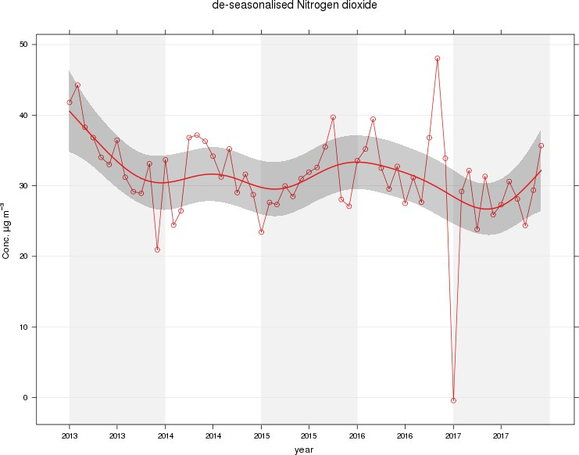

Figure 2 – A5 Falkirk Hope St Long Term NO₂ Concentrations
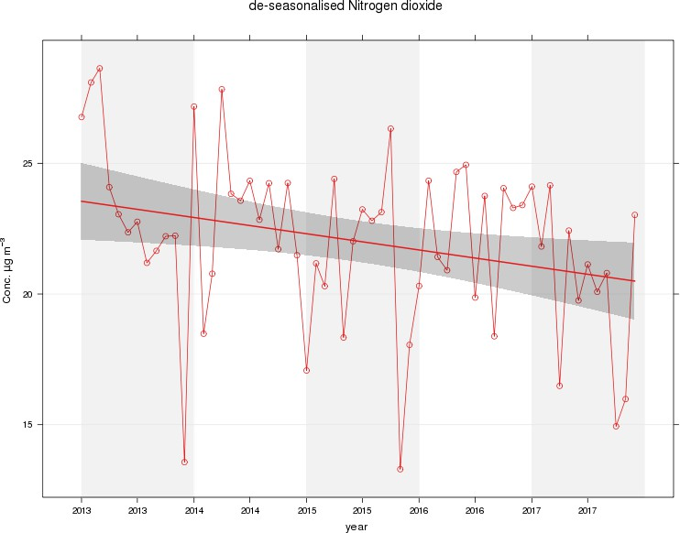

Figure 3 – A7 Falkirk West Bridge St Long Term NO₂ Concentrations
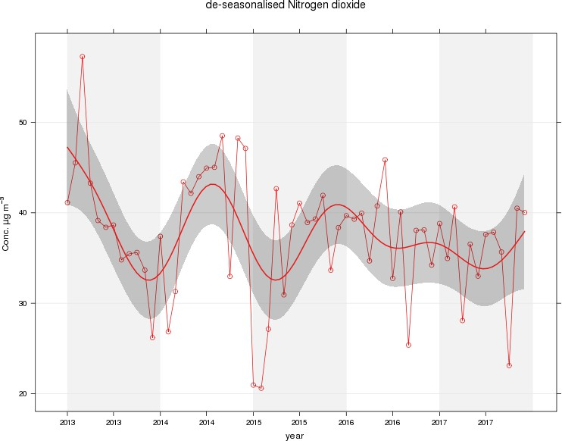

Figure 4 – A8 Grangemouth AURN Long Term NO₂ Concentrations
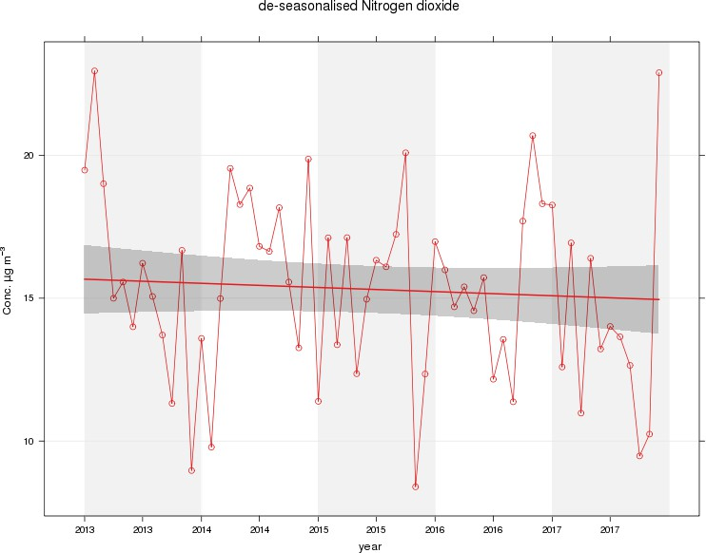

Figure 5 – A9 Grangemouth Moray Long Term NO₂ Concentrations
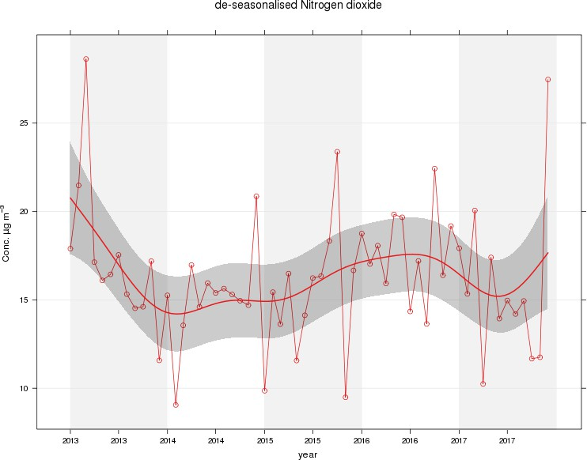

Figure 6 – A9 Grangemouth Municipal Chambers Long Term NO₂ Concentrations
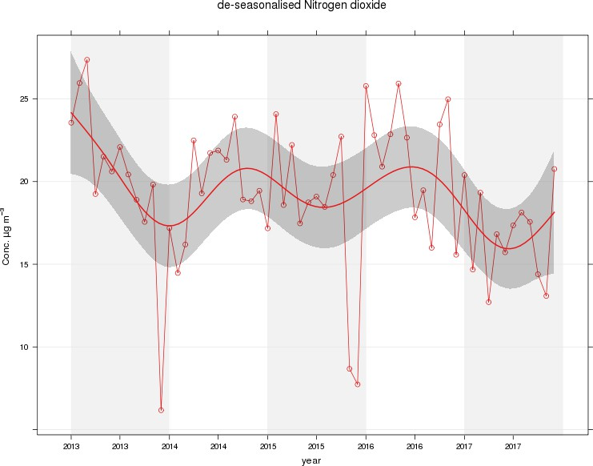

Table A.5 – Annual Mean PM₁₀ Monitoring Results

Site ID | Site Type | Valid Data Capture  for Monitoring Period (%) ⁽¹⁾ | Valid Data Capture 2017  (%) (2) | PM₁₀ Annual Mean Concentration (µg/m³) ⁽³⁾
 |  |  |  | 2013 | 2014 | 2015 | 2016 | 2017
A4 | Falkirk Haggs | 95 | 95 | 18.3 | 16.5 | 15 | 14 | 12
A7 | Falkirk West Bridge St | 88 | 88 | 19.5 | 17.7 | 15 | 15 | 10
A8 | Grangemouth AURN | 95 | 95 | 14 | 12.4 | 12.2 | 11 | 9
A10 | Grangemouth Municipal Chambers | 85 | 85 | 15 | 14.6 | 13 | 13 | 12
A12 | Falkirk Grahams Road | 98 | 98 | 16.3 | 13.2 | 11.8 | 13 | 12
A13 | Banknock 2 | 99 | 99 | 16.3 | 13.2 | 11 | 11 | 13
A14 | Banknock 3 | 17 | 17 | 14.6 | 15 | 8.2 | n/m | 7
A15 | Main St, Bainsford | 94 | 94 | n/m | n/m | 12.8 | 10 | 13

Notes: Exceedences of the PM₁₀ annual mean objective of 18µg/m³ are shown in bold.
- Data capture for the monitoring period, in cases where monitoring was only carried out for part of the year.
- Data capture for the full calendar year (e.g. if monitoring was carried out for 6 months, the maximum data capture for the full calendar year is 50%).
- All means have been “annualised” as per LAQM.TG (16), valid data capture for the full calendar year is less than 75%. See Appendix C for details.

Table A.6 – 24-Hour Mean PM₁₀ Monitoring Results

Site ID | Site Type | Valid Data Capture  for Monitoring Period (%) ⁽¹⁾ | Valid Data Capture 2017 (%)  (2) | PM₁₀ 24-Hour Means > 50µg/m³ ⁽³⁾
 |  |  |  | 2013 | 2014 | 2015 | 2016 | 2017
A4 | Falkirk Haggs | 95 | 95 | 4 | 1 | 1 | 0 | 0
A7 | Falkirk West Bridge St | 88 | 88 | 4 | 2 (40) | 2 (29) | 0 | 0
A8 | Grangemouth AURN | 95 | 95 | 0 (34) | 0 | 1 (21) | 0 | 1
A10 | Grangemouth Municipal Chambers | 85 | 85 | 0 (32) | 0 | 0 | 0 | 0
A12 | Falkirk Grahams Road | 98 | 98 | 3 | 0 | 0 (18) | 0 | 0
A13 | Banknock 2 | 99 | 99 | 0 | 3 | 4 | n/m | 7
A14 | Banknock 3 | 17 | 17 | 0 (22) | 0 (24) | 1 | 3 | 0
A15 | Main St, Bainsford | 94 | 94 | n/m | n/m | 0 (16) | 0 (16) | 0

Notes: Exceedences of the PM₁₀ 24-hour mean objective (50µg/m³ not to be exceeded more than 7 times/year) are shown in bold.
- Data capture for the monitoring period, in cases where monitoring was only carried out for part of the year.
- Data capture for the full calendar year (e.g. if monitoring was carried out for 6 months, the maximum data capture for the full calendar year is 50%).
- If the period of valid data is less than 85%, the 98.1st percentile of 24-hour means is provided in brackets.

Figure 7 – A4 Falkirk Haggs Long Term PM₁₀ Concentrations
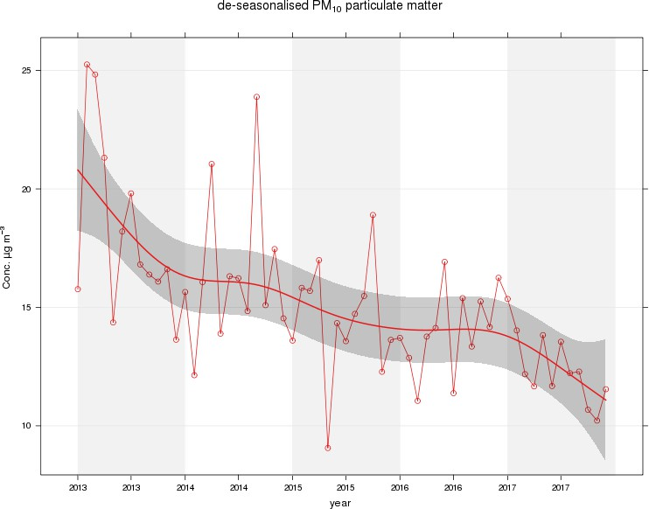

Figure 8 – A7 Falkirk West Bridge St Long Term PM₁₀ Concentrations
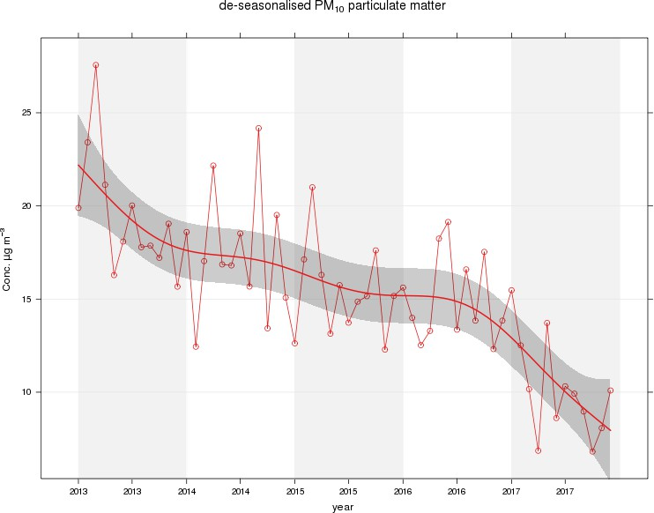

Figure 9 – A8 Grangemouth AURN Long Term PM₁₀ Concentrations
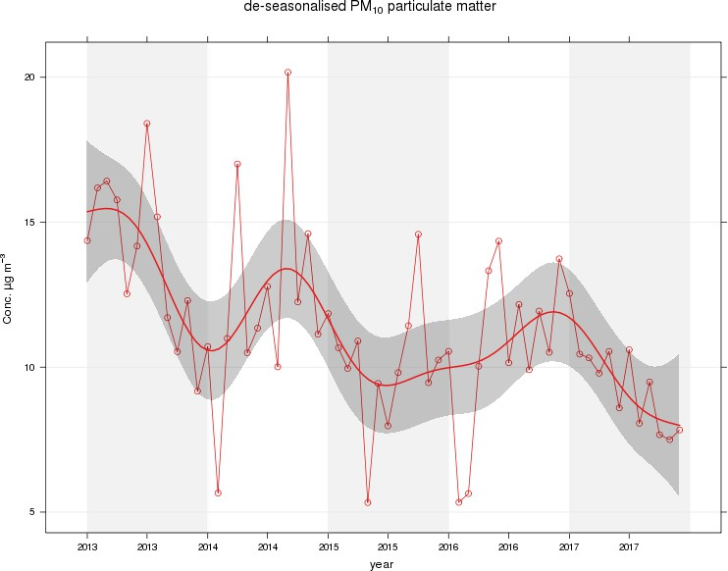

Figure 10 – A10 Grangemouth Municipal Chambers Long Term PM₁₀ Concentrations
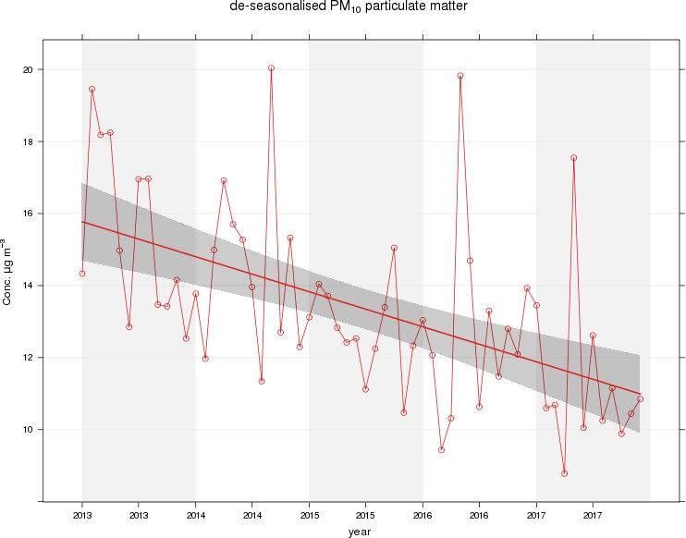

Figure 11 – A13 Banknock 2 Long Term PM₁₀ Concentrations
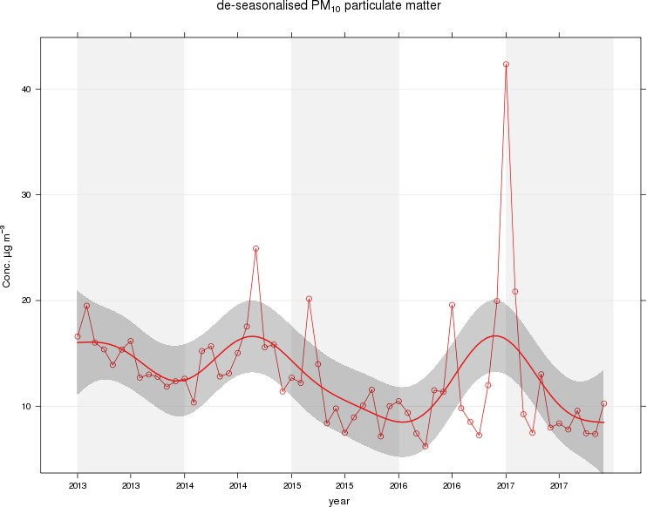

Table A.7 – Annual Mean PM_{2.5} Monitoring Results

Site ID | Site Type | Valid Data Capture  for Monitoring Period (%) ⁽¹⁾ | Valid Data Capture 2017  (%) (2) | PM_{2.5} Annual Mean Concentration (µg/m³) ⁽³⁾
 |  |  |  | 2013 | 2014 | 2015 | 2016 | 2017
A7 | Falkirk West Bridge St | 88 | 88 | n/m | n/m | n/m | 6 | 6
A8 | Grangemouth AURN | 95 | 95 | 9.2 | 8.0 | 9.2 | 6 | 6
A13 | Banknock 2 | 99 | 99 | n/m | n/m | 6 | 5 | 6

Notes: Exceedences of the PM₁₀ annual mean objective of 10µg/m³ are shown in bold.
- Data capture for the monitoring period, in cases where monitoring was only carried out for part of the year.
- Data capture for the full calendar year (e.g. if monitoring was carried out for 6 months, the maximum data capture for the full calendar year is 50%).
- All means have been “annualised” as per LAQM.TG (16), valid data capture for the full calendar year is less than 75%. See Appendix C for details.

Figure 12 – A7 Falkirk West Bridge St Long Term PM_{2.5} Concentrations
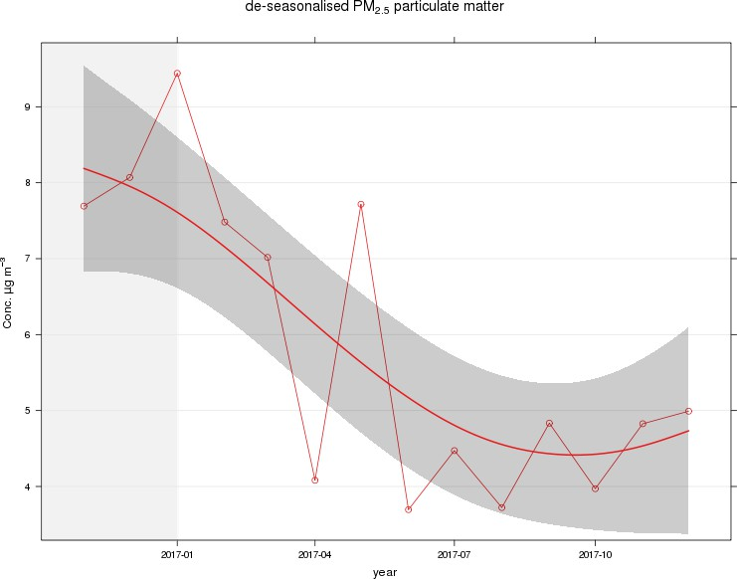

Figure 13 – A8 Grangemouth AURN Long Term PM_{2.5} Concentrations
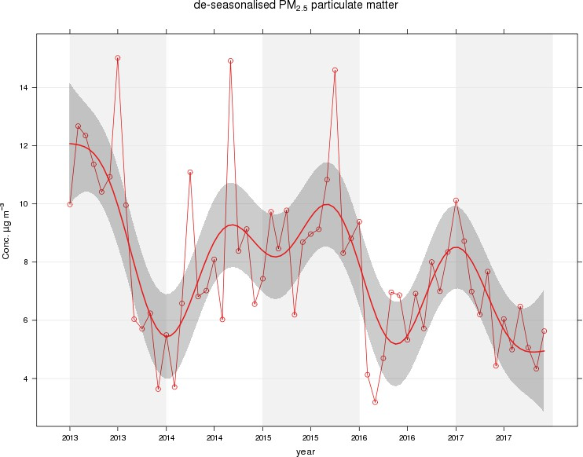

Figure 14 – A13 Banknock 2 Long Term PM_{2.5} Concentrations
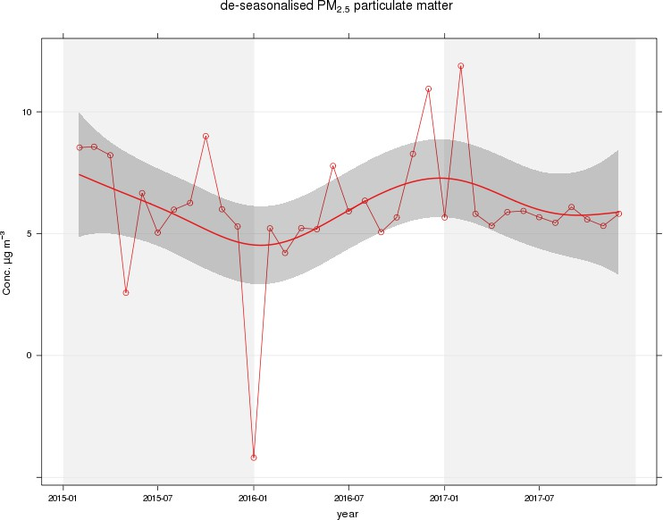

Table A.8 – SO₂ Monitoring Results

Site ID | Site Type | Valid Data Capture for monitoring Period (%) ⁽¹⁾ | Valid Data Capture 2017 (%) ⁽²⁾ | Number of Exceedences  (percentile in bracket) ⁽³⁾
 |  |  |  | 15-minute Objective (266 µg/m³) | 1-hour Objective (350 µg/m³) | 24-hour Objective (125 µg/m³)
A3 | Bo’ness | 92 | 92 | 0 | 0 | 0
A5 | Falkirk Hope St | 89 | 89 | 0 | 0 | 0
A8 | Grangemouth AURN | 95 | 95 | 0 | 0 | 0
A9 | Grangemouth Moray | 89 | 89 | 10 | 0 | 0
A10 | Grangemouth Municipal Chambers | 97 | 97 | 4 | 0 | 0
A11 | Grangemouth Zetland Park | 91 | 91 | 0 | 0 | 0

Notes: Exceedences of the SO₂ objectives are shown in bold (15-min mean = 35 allowed a year, 1-hour mean = 24 allowed a year, 24-hour mean = 3 allowed a year)
- Data capture for the monitoring period, in cases where monitoring was only carried out for part of the year.
- Data capture for the full calendar year (e.g. if monitoring was carried out for 6 months, the maximum data capture for the full calendar year is 50%)
- If the period of valid data is less than 85%, the relevant percentiles are provided in brackets.

Figure 15 – A3 Bo’ness Long Term SO₂ Concentrations
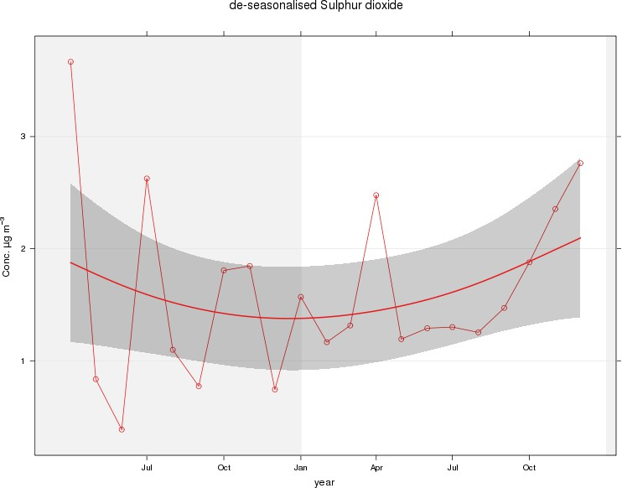

Figure 16 – A8 Falkirk Hope St Long Term SO₂ Concentrations
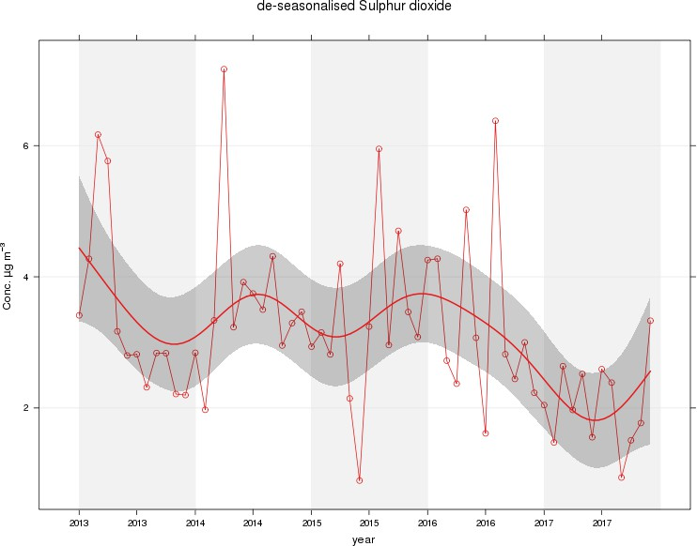

Figure 17 – A5 Grangemouth AURN Long Term SO₂ Concentrations
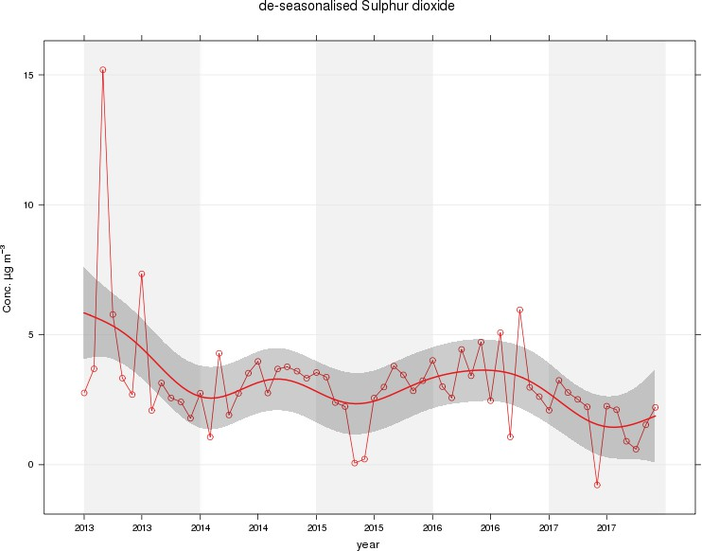

Figure 18 – A9 Grangemouth Moray Long Term SO₂ Concentrations
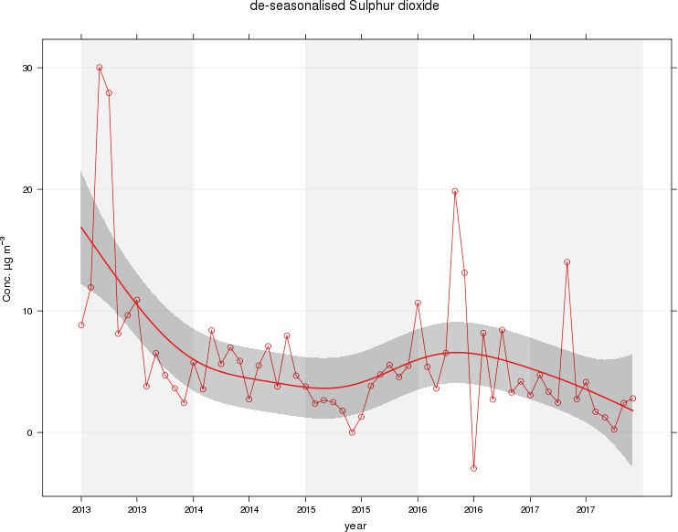

Figure 19 – A10 Grangemouth Municipal Chambers Long Term SO₂ Concentrations
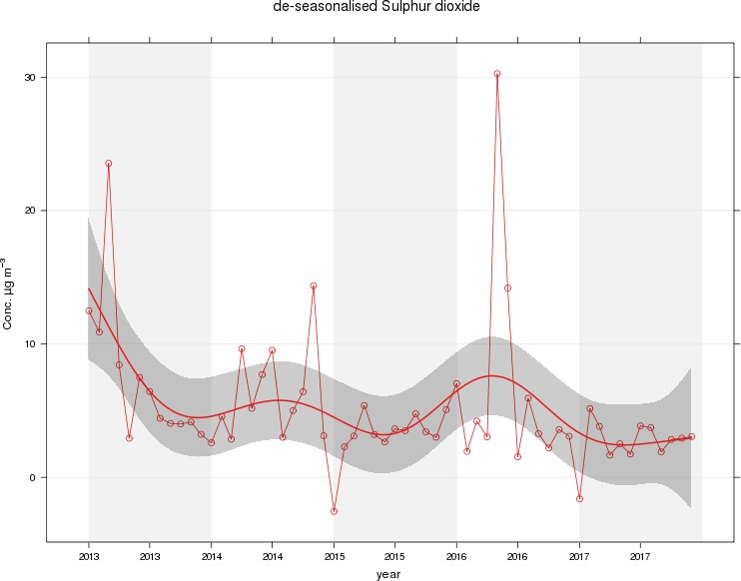

Figure 20 – A11 Grangemouth Zetland Park Long Term SO₂ Concentrations
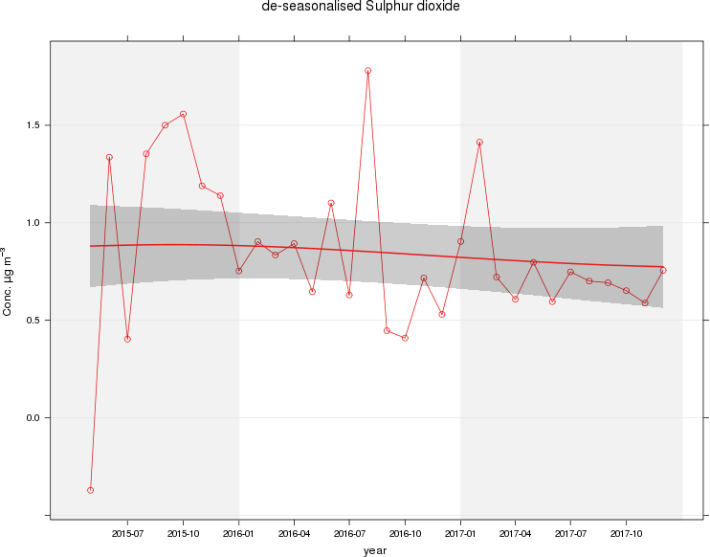

Figure 21 – Polar plots of average SO₂ concentrations in the Grangemouth sites
A) Grangemouth AURN: 2017 B) Grangemouth AURN: 2013 – 2017
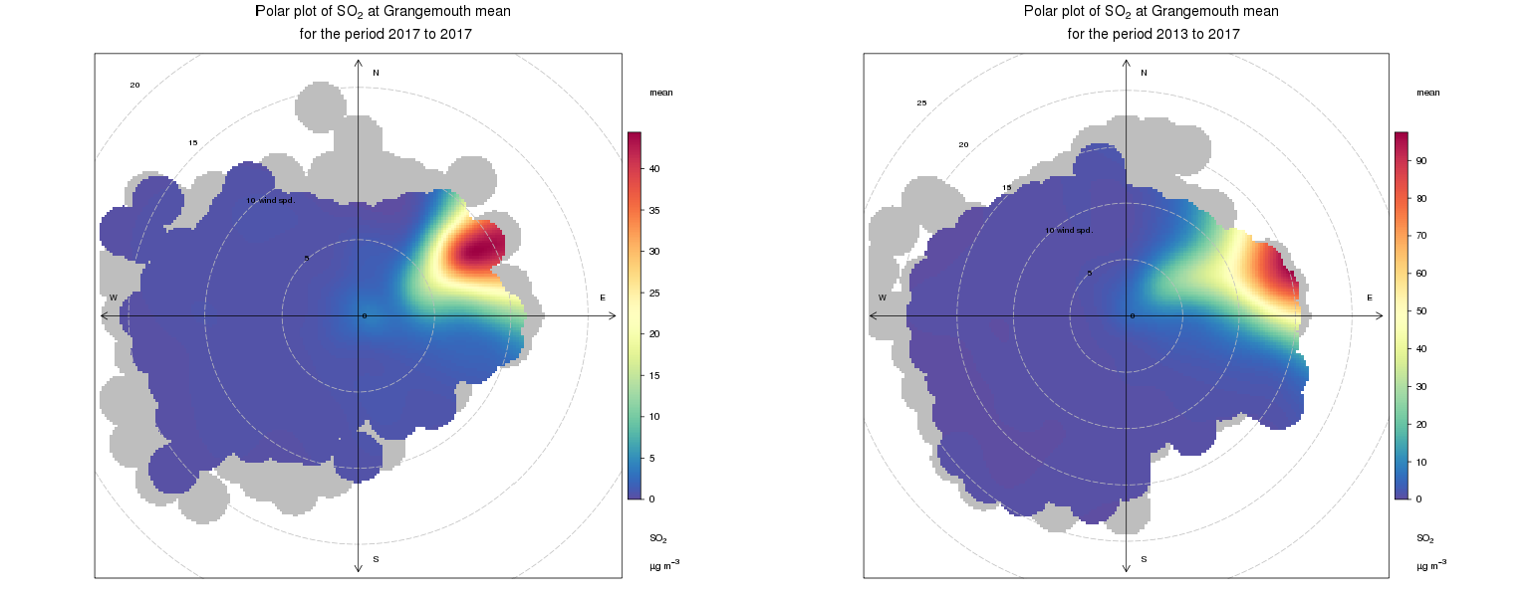

C) Grangemouth Moray: 2017 D) Grangemouth Moray: 2013 – 2017
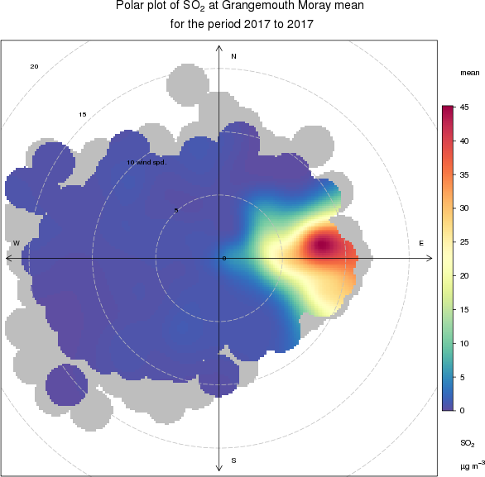
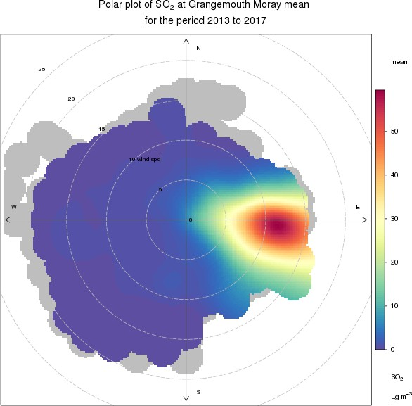

E) Grangemouth Municipal Chambers: 2017 F) Grangemouth Municipal Chambers: 2013 – 2017
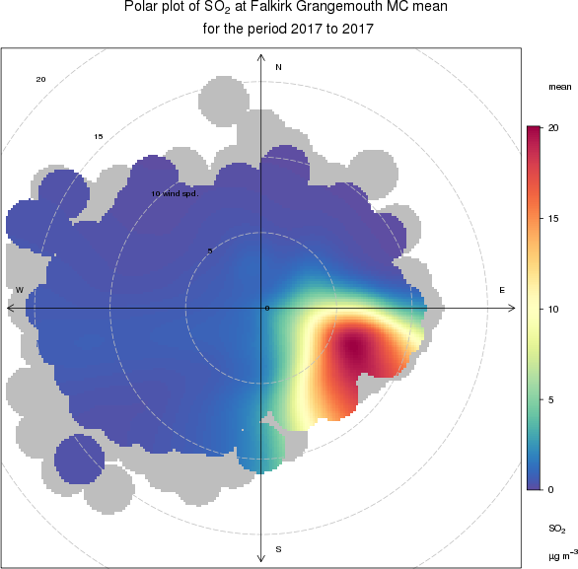
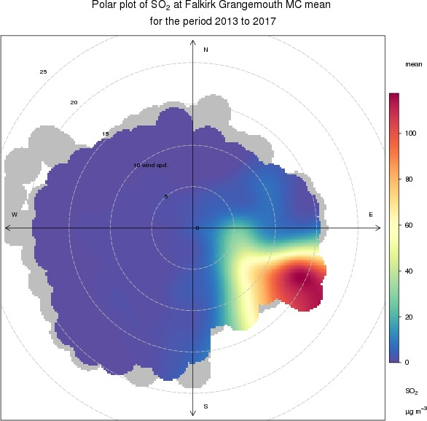

Figure 22 – Exceedances of the 15minute air quality objective concentration at the Grangemouth sites 2013 – 2017
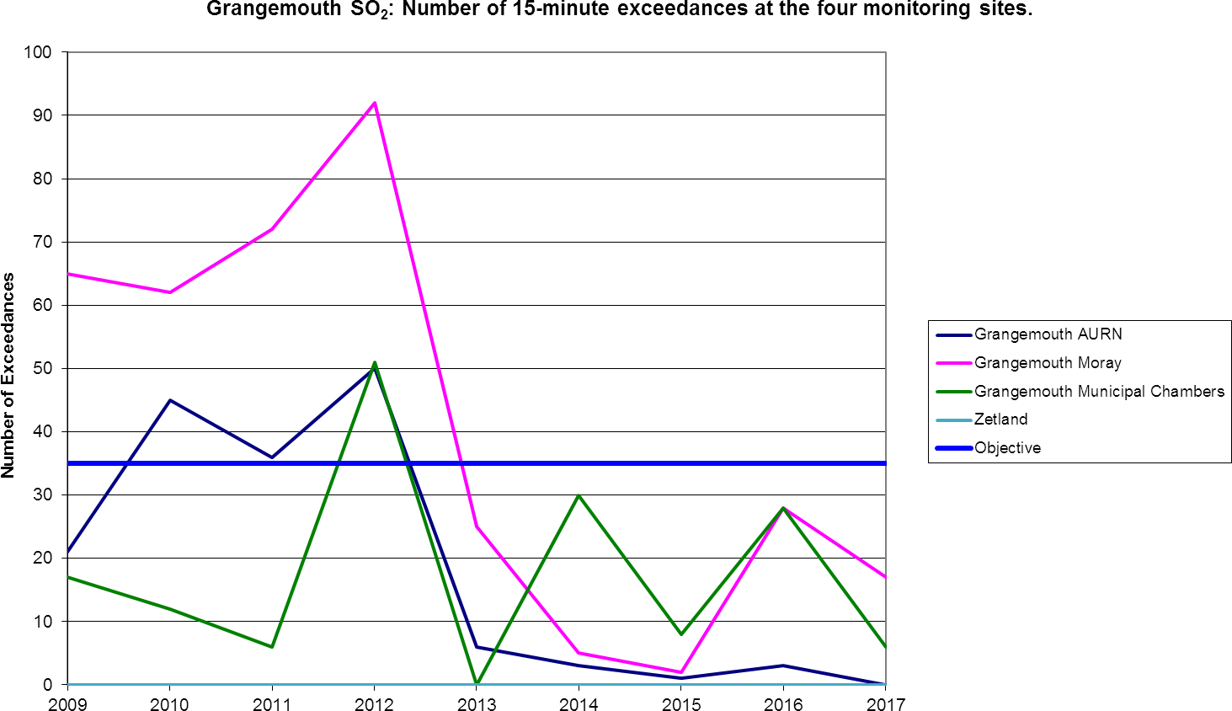

Table A. 9 – 1, 3 Butadiene Annual Mean Diffusion Tube Results for 2017

Site ID | Location | Within 1,  3  butadiene AQMA? | Data capture in 2017, %.(1) | Annual mean concentrations (µg/m3)
 |  |  |  | 2013 | 2014 | 2015 | 2016 | 2017
NA41 | Seaview Place, Bo’ness | N | 91.7 | 1.25 | 0.42 | 0.11 | 0.10 | 0.1
NA55 | Inchyra Station,  Grangemouth | N | 91.7 | 1.25 | 0.48 | 0.09 | 0.10 | 0.07
NA104 | Powdrake Road, Grangemouth | N | 100 | 1.25 | 0.47 | 0.13 | 0.11 | 0.1
Note: Exceedences of the 1, 3- butadiene running annual mean objective of 2.25µg/m³ are shown in bold.

Table A. 10 – Benzene Annual Mean Diffusion Tube Results for 2017

Site ID | Location | Within Benzene AQMA? | Data captu re in 2017,  %.(1) | Annual mean concentrations (µg/m3)
 |  |  |  | 2013 | 2014 | 2015 | 2016 | 2017
NA3 | Tinto Drive, Grangemouth | N | 91.7 | 1.39 | 1.3 | 1.16 | 0.51 | 0.58
NA21 | Grangemouth Road, Falkirk College | N | 100 | 1.25 | 1.13 | 0.72 | 0.46 | 0.56
NA27 | West Bridge Street, Falkirk | N | 100 | 1.52 | 2.39 | 0.69 | 0.78 | 0.68
NA37 | Denny Town House | N | 100 | 1.16 | 1.09 | 0.59 | 0.58 | 0.56
NA38 | Larbert Village Primary School | N | 91.7 | 0.85 | 1.04 | 0.55 | 0.51 | 1.01
NA41 | Seaview Place, Bo’ness | N | 91.7 | 1.84 | 1.97 | 0.91 | 1.11 | 0.82
NA42 | Municipal Chambers, Grangemouth | N | 100 | 1.59 | 1.25 | 0.69 | 0.79 | 0.47
NA44 | Harvey Avenue, Polmont | N | 50 | 1.16 | 1.34 | 0.56 | 0.48 | 0.39
NA55 | Inchyra AQ Station, Grangemouth | N | 91.7 | 1.38 | 1.32 | 0.5 | 0.46 | 0.52
NA57 | Inchyra Road, Grangemouth | N | 91.7 | 1.33 | 1.96 | 0.69 | 0.90 | 0.57
NA77 | Kinnaird Village | N | 91.7 | 1.12 | 1.04 | 0.65 | 0.44 | 0.51
NA80 | Cow Wynd, Falkirk | N | 91.7 | 1.53 | 1.33 | 0.81 | 0.56 | 0.57
NA81 | Grahams Road, Falkirk | N | 91.7 | 1.47 | 1.25 | 0.88 | 0.95 | 0.7
NA94 | A905 (Glensburgh Rd), Grangemouth | N | 91.7 | 1.71 | 1.13 | 0.68 | 0.78 | 0.64
NA102 | East Kerse Mains, Bo’ness | N | 83.3 | 1.35 | 1.26 | 0.61 | 0.49 | 0.44
NA105 | West of Shieldhill | N | 83.3 | 0.69 | 0.74 | 0.34 | 0.19 | 0.69
Note: Exceedences of the Benzene running annual mean objective of 3.25µg/m³ are shown in bold.

Table A. 11 – Pumped Benzene Annual Mean Results for 2017

Site ID | Location | Within Benzene AQMA? | Data capture in 2017, % (1) | Annual mean concentrations (µg/m3)
 |  |  |  | 2013 | 2014 | 2015 | 2016 | 2017
A8 | Grangemouth AURN | N | 100 | 1.13 | 0.99 | 0.73 | 0.64 | 0.65
Note: Exceedences of the Benzene running annual mean objective of 3.25µg/m³ are shown in bold.

Table A. 12 – Estimated Annual Mean PM_{2.5} Results 2017

Site ID | Site Type | Valid Data Capture for Monitoring Period (%) (1) | Valid Data Capture in 2017 (%)  (2) | Correction Factor | Estimated PM2.5 Annual Mean Concentration (µg/m3) (3)
 |  |  |  |  | 2013 | 2014 | 2015 | 2016 | 2017
A4 Falkirk Haggs | Roadside (Non-urban) | 95 | 95 | 0.46 | 8.45 | 7.62 | 6.92 | 6.46 | 5.54
A10 Grangemouth  Municipal Chambers | Urban  Background/ Industrial | 85 | 85 | 0.67 | 10.00 | 9.73 | 8.67 | 8.67 | 8.00
A12 Falkirk Graham’s Road | Roadside (Urban) | 98 | 98 | 0.60 | 9.78 | 7.92 | 7.08 | 7.80 | 7.20
A14 Banknock 3 | Roadside (Non-urban) | 17 | 17 | 0.46 | 6.74 | 6.92 | 3.78 | n/m | 3.05
A15 Main St Bainsford | Roadside (Urban) | 94 | 94 | 0.60 | n/m | n/m | 7.68 | 6.00 | 7.80
Note: Exceedences of the PM2.5 annual mean objective of 10µg/m³ are shown in bold.
- Data capture for the monitoring period, in cases where monitoring was only carried out for part of the year.
- Data capture for the full calendar year (e.g. if monitoring was carried out for 6 months, the maximum data capture for the full calendar year is 50%)
- All means have been estimated using a local correction factor as per LAQM.TG (16). See Appendix C for details.

Figure 23 – Maps of AQMA Boundaries in the Falkirk Council area
- Grangemouth AQMA (SO₂ 15-min mean), declared November 2005
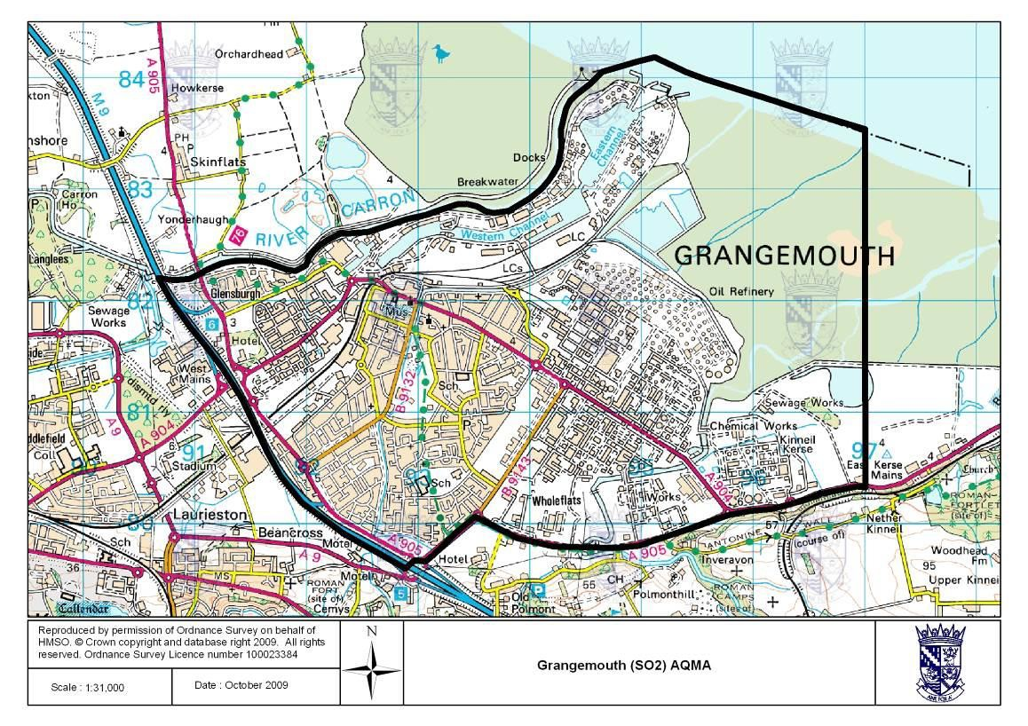
- Falkirk Town Centre AQMA (NO₂ Annual Mean, PM₁₀ annual and 24-hour mean), declared March 2010
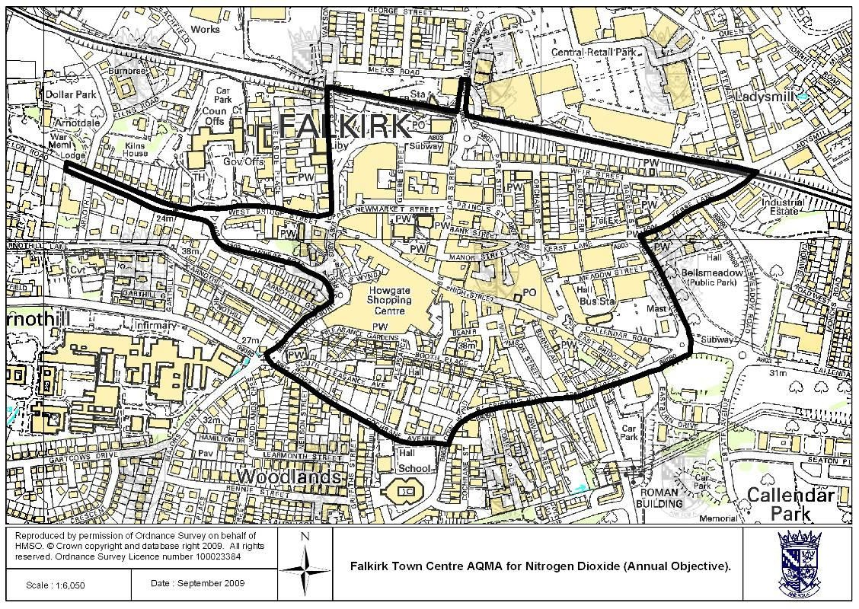

- Haggs AQMA (NO₂ annual mean), declared March 2010
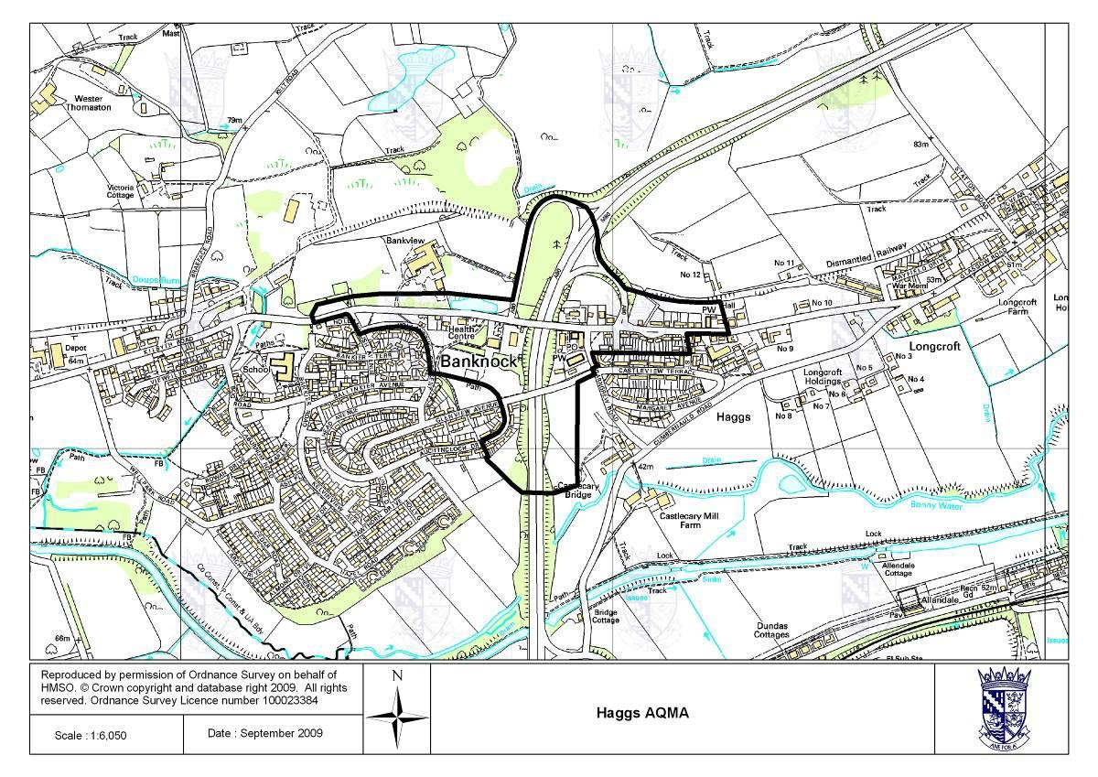
- Banknock AQMA (PM₁₀ 24-hour mean), declared August 2011
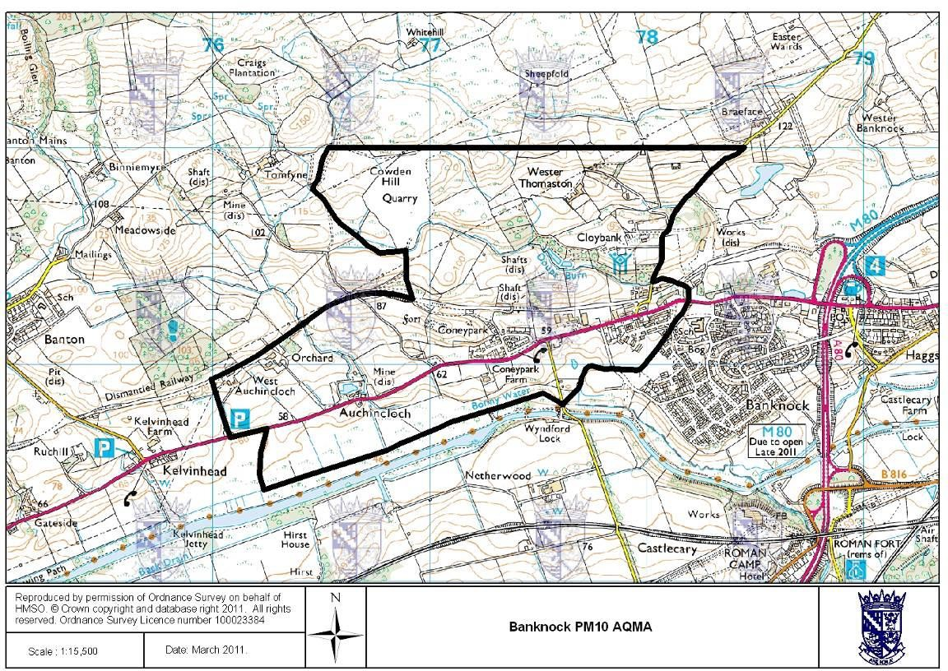

Figure 24 – Maps Showing Automatic Monitoring Locations

  - Grangemouth Air Quality (AQ) Stations
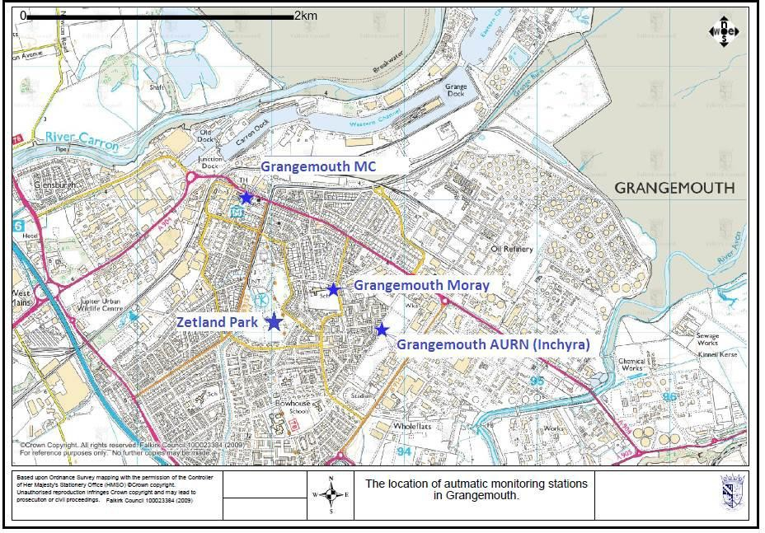

  - Falkirk Hope St AQ Station
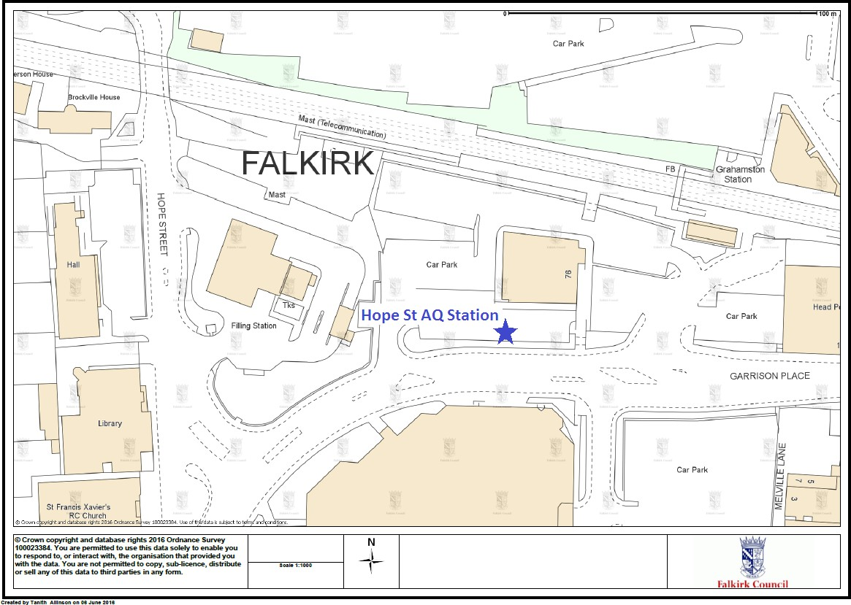

  - Falkirk West Bridge St AQ Station
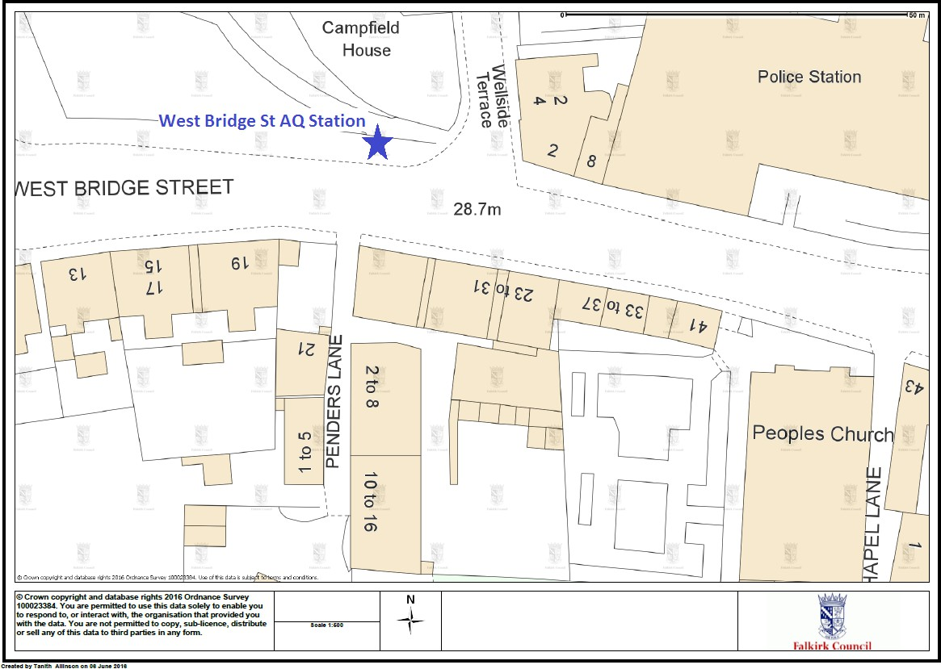

  - Bo’ness AQ Station
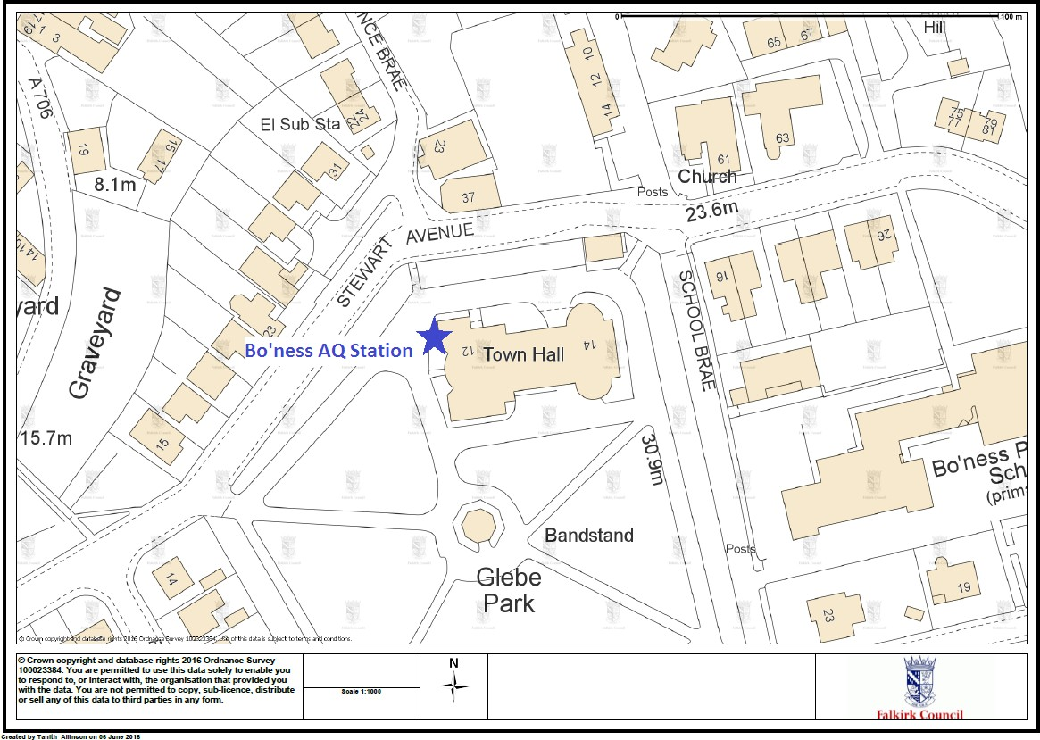

  - Falkirk Haggs AQ Station
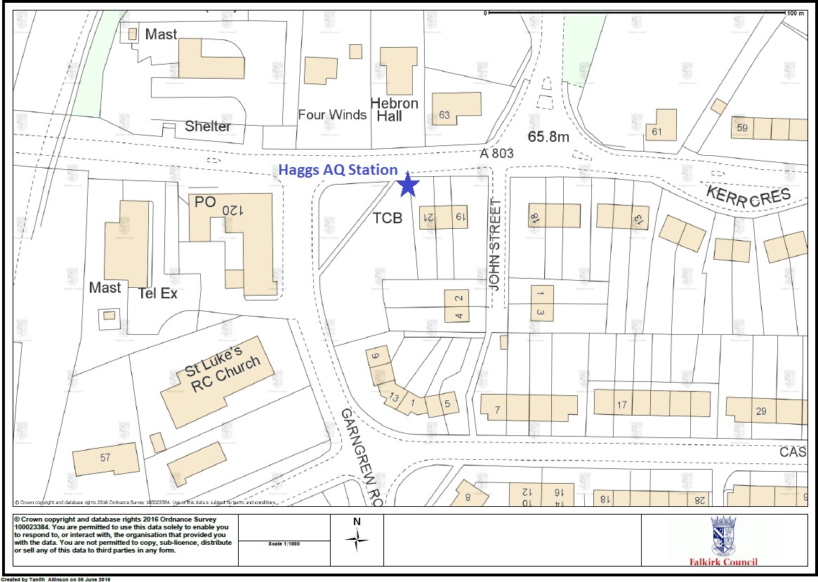

  - Banknock 2 AQ Station
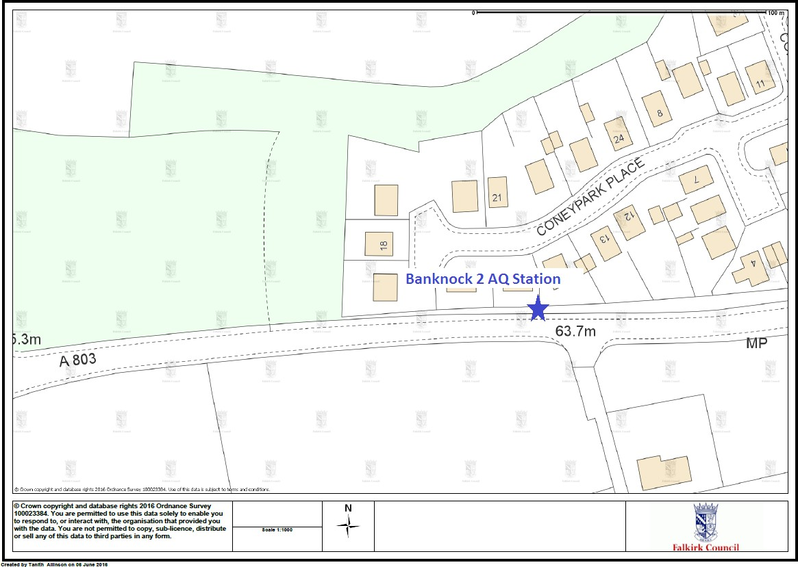

  - Falkirk Grahams Rd AQ Station
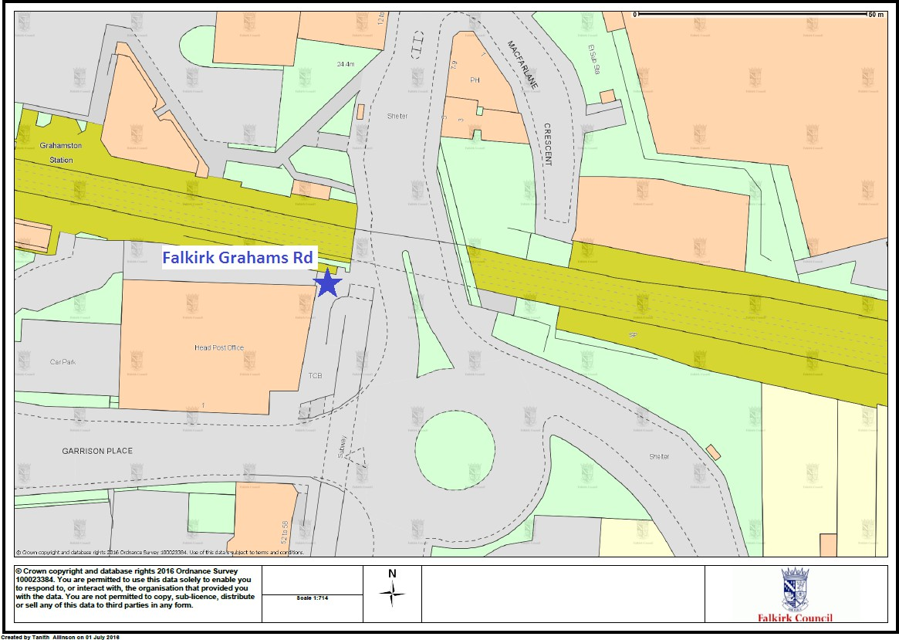

  - Main St, Bainsford, Falkirk AQ Station
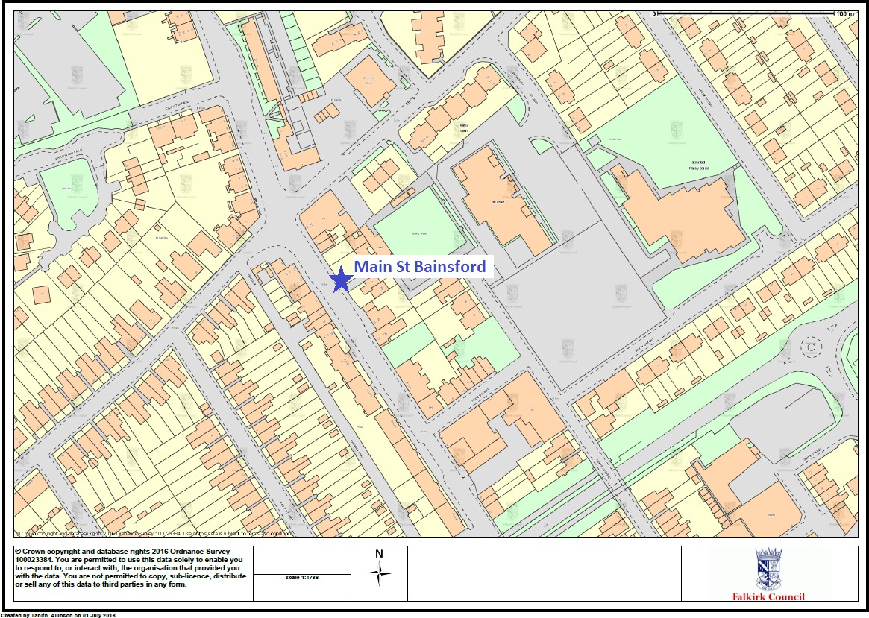

Appendix B: Full Monthly Diffusion Tube Results for 2017

Table B.1 – NO₂ Monthly Diffusion Tube Results for 2017

Site ID | NO₂ Mean Concentrations (µg/m³)
Site ID | Jan | Feb | Mar | Apr | May | Jun | Jul | Aug | Sep | Oct | Nov | Dec | Annual Mean
 |  |  |  |  |  |  |  |  |  |  |  |  | Raw Data | Bias Adjusted  (1)
NA3 | 32.43 | 21.49 | 22.14 | 14.41 | 14.38 | 11.42 | 11.89 | 13.96 | 16.29 | 16.96 | 23.19 | 31.90 | 19 | 18
NA5 | 36.34 | 26.84 | 26.59 | - | 21.63 | 18.07 | 17.55 | 20.22 | 24.64 | 25.97 | 30.38 | 37.74 | 26 | 24
NA7 | 27.98 | 18.93 | 19.96 | 9.77 | 12.94 | 10.72 | 9.83 | 9.48 | 16.28 | 16.01 | 18.94 | 22.01 | 16 | 15
NA9 | 31.00 | 28.16 | 31.76 | 23.48 | 18.72 | 18.81 | 16.92 | 18.29 | 23.31 | 24.00 | 33.53 | 35.68 | 25 | 24
NA19 | 31.01 | 37.90 | 32.73 | 20.41 | 26.64 | 17.52 | 23.11 | 20.88 | 27.20 | 25.76 | 30.86 | 38.30 | 28 | 26
NA20 | 32.89 | 23.91 | 27.55 | 16.89 | 15.07 | 14.75 | 16.85 | 20.65 | 22.15 | 23.14 | 30.28 | 34.73 | 23 | 22
NA21 | 74.46 | 30.76 | 31.05 | 17.89 | 22.62 | 19.17 | 18.14 | 20.56 | 25.00 | 24.63 | 31.48 | 43.31 | 30 | 28
NA24 | 95.05 | 35.99 | 41.38 | 37.94 | 31.29 | 28.62 | 24.86 | 31.85 | 35.67 | 35.79 | 44.23 | 57.27 | 42 | 39
NA26 | 26.31 | 22.53 | - | 13.45 | 14.06 | 11.20 | 14.19 | 14.35 | 16.32 | 17.54 | 20.66 | 30.44 | 18 | 17
NA27 | 49.49 | 50.38 | 49.80 | 35.96 | 40.88 | 32.99 | 33.88 | 33.00 | 40.78 | 32.81 | 42.26 | 46.84 | 41 | 38
NA29 | 49.39 | 23.60 | 18.37 | 9.31 | 11.69 | 9.79 | 12.36 | 10.99 | 18.96 | 15.45 | 20.21 | 25.00 | 19 | 17
NA36 | 46.03 | 39.40 | 45.07 | 32.21 | 29.72 | - | 28.19 | 33.56 | 34.45 | 35.96 | 39.68 | 46.47 | 37 | 35
NA37 | 22.28 | 21.39 | 17.40 | 12.08 | 15.56 | 10.34 | 10.93 | 12.58 | 17.27 | 14.43 | 17.47 | 23.44 | 16 | 15
NA38 | 24.35 | 19.48 | 21.46 | 10.32 | 10.97 | 9.62 | 0.11 | 13.04 | 15.37 | 15.98 | 21.41 | 31.49 | 16 | 15
NA41 | 27.95 | 22.97 | 22.78 | 17.91 | 16.94 | 15.44 | 15.09 | 16.51 | 19.15 | 20.63 | 27.42 | 35.51 | 22 | 20
NA42 (3 Tubes) | 28.13 | 20.57 | 21.74 | 12.47 | 14.19 | 10.76 | 12.44 | 14.14 | 15.27 | 16.58 | 24.50 | 27.99 | 18 | 17
NA42 (3 Tubes) | 30.01 | 20.30 | 20.55 | 11.12 | 12.57 | 11.49 | 11.53 | 12.59 | 15.88 | 16.24 | 23.96 | 26.49 | 18 | 17

Site ID | NO₂ Mean Concentrations (µg/m³)
Site ID | Jan | Feb | Mar | Apr | May | Jun | Jul | Aug | Sep | Oct | Nov | Dec | Annual Mean
 |  |  |  |  |  |  |  |  |  |  |  |  | Raw Data | Bias Adjusted  (1)
NA42 | 30.59 | 20.90 | 18.97 | 12.80 | 13.02 | 10.53 | 11.65 | 13.28 | 15.36 | 16.59 | 23.20 | 29.43 | 18 | 17
NA44 | - | - | 20.13 | - | 10.11 | 12.25 | 12.52 | 14.20 | 15.73 | 18.44 | 23.41 | 28.21 | 17 | 16
NA48 | 25.48 | 19.12 | 22.03 | 10.82 | 14.27 | 11.55 | 12.93 | 13.49 | 15.55 | 15.34 | 20.93 | 26.73 | 17 | 16
NA50 | 26.31 | 25.21 | 25.90 | - | - | 16.23 | 13.87 | 16.79 | 21.68 | 20.90 | 22.01 | 28.08 | 22 | 20
NA51 | 31.81 | 27.08 | 27.79 | 18.86 | 19.82 | 17.41 | 15.60 | 18.00 | 23.04 | 22.79 | 28.15 | 33.91 | 24 | 22
NA52 | 33.45 | 27.96 | 24.56 | 16.88 | 19.39 | 15.67 | 11.08 | 20.35 | 22.72 | 20.66 | 27.23 | 33.97 | 23 | 21
NA53 | 27.29 | 37.06 | 28.69 | 17.26 | 25.79 | 16.79 | - | 19.36 | 24.12 | 23.66 | 23.30 | 32.81 | 25 | 23
NA57 | 24.98 | 23.27 | 24.74 | 15.67 | 14.26 | 13.39 | 13.25 | 14.39 | 18.74 | 17.87 | 23.95 | 37.33 | 20 | 19
NA58 | 26.50 | 25.57 | - | - | 29.32 | 15.30 | - | 12.84 | 20.86 | 20.88 | 29.34 | 34.55 | 24 | 22
NA59 | 83.93 | 17.28 | - | - | 22.12 | 17.77 | 17.57 | 20.47 | 24.66 | 24.71 | - | 41.86 | 30 | 28
NA60 | 35.55 | 28.16 | 27.90 | 19.37 | 19.20 | 16.83 | 16.83 | 19.09 | 24.19 | 23.74 | 32.28 | 38.08 | 25 | 23
NA61 | 34.72 | 26.25 | 25.55 | 14.17 | 15.90 | 16.66 | 15.89 | 19.04 | 21.95 | 20.86 | 13.85 | 32.69 | 21 | 20
NA62 | 49.52 | 41.39 | 42.58 | 32.04 | 31.40 | 29.95 | 25.91 | 32.40 | 33.87 | 36.02 | 39.77 | 47.81 | 37 | 34
NA63 | 45.53 | 40.38 | 40.03 | 30.58 | 30.46 | 25.61 | - | 26.05 | 28.63 | 34.66 | 40.99 | 48.36 | 36 | 33
NA64 | 21.63 | 20.37 | 16.82 | 10.55 | 12.26 | 10.18 | 12.42 | 10.42 | 14.65 | 11.97 | 15.96 | 22.31 | 15 | 14
NA65 | 33.80 | 29.61 | 27.74 | 21.12 | 19.75 | 17.42 | 18.39 | 18.80 | 22.97 | 21.36 | 26.01 | 37.69 | 25 | 23
NA67 | 26.10 | 32.70 | 32.97 | 25.38 | 26.35 | 20.48 | 20.14 | 24.21 | 26.29 | 27.28 | 33.85 | 46.49 | 29 | 27
NA68 | 33.39 | 29.28 | 34.89 | 23.68 | 22.40 | 24.23 | 20.47 | 20.43 | 28.80 | 30.24 | 37.85 | 44.12 | 29 | 27
NA69 | 37.40 | 37.77 | 37.70 | 28.09 | 27.64 | 24.74 | 24.63 | 25.25 | 32.01 | 28.22 | 31.69 | 47.48 | 32 | 30

Site ID | NO₂ Mean Concentrations (µg/m³)
Site ID | Jan | Feb | Mar | Apr | May | Jun | Jul | Aug | Sep | Oct | Nov | Dec | Annual Mean
 |  |  |  |  |  |  |  |  |  |  |  |  | Raw Data | Bias Adjusted  (1)
NA71 | 44.13 | 33.75 | 35.29 | 30.24 | 24.95 | 24.34 | 22.83 | 28.13 | 29.86 | 30.58 | 37.15 | 49.68 | 33 | 30
NA72 | - | 32.55 | 29.07 | 19.89 | 25.27 | 24.75 | 16.32 | 22.75 | 27.99 | 26.54 | 32.95 | 42.64 | 27 | 25
NA73 | 36.13 | 36.19 | 31.93 | 22.05 | 33.49 | 24.81 | 25.77 | 26.52 | 28.76 | 27.95 | 30.37 | 38.79 | 30 | 28
NA76 | 32.59 | - | 23.09 | 15.78 | 18.45 | 12.69 | 10.91 | 16.19 | 19.88 | 18.95 | 28.49 | 27.68 | 20 | 19
NA77 | 27.20 | 23.92 | 25.09 | - | - | 14.86 | 13.01 | 17.64 | 22.51 | 20.33 | 27.18 | 30.60 | 22 | 21
NA78 | 40.36 | 35.12 | 30.55 | 13.48 | 26.24 | 23.99 | 24.76 | 29.27 | 31.49 | - | 35.62 | 38.88 | 30 | 28
NA80 | 46.28 | 35.45 | 35.05 | 25.04 | 22.99 | 21.53 | 20.84 | 28.10 | 28.81 | 30.04 | 37.33 | 42.49 | 31 | 29
NA81 | 34.78 | 36.17 | 33.66 | 28.40 | 23.41 | 20.24 | 22.46 | 22.93 | 40.64 | 26.08 | 29.77 | 41.36 | 30 | 28
NA82 | 24.61 | 24.66 | 20.50 | 13.02 | 14.25 | 10.79 | 9.47 | 13.37 | 14.39 | 15.24 | 20.63 | 35.20 | 18 | 17
NA83 | 40.87 | 38.47 | 40.85 | 31.22 | - | 28.45 | 11.72 | 30.21 | 33.30 | - | - | 44.61 | 33 | 31
NA85 | 21.97 | 24.39 | 23.13 | 9.23 | 19.92 | 11.81 | 15.50 | 13.78 | 17.83 | 15.85 | 18.18 | 27.72 | 18 | 17
NA86 | 25.49 | 18.78 | 21.09 | 16.61 | 14.31 | 9.71 | 9.72 | 9.95 | 13.58 | 14.04 | 20.26 | 25.21 | 17 | 15
NA87 | 36.66 | 33.85 | 30.71 | 22.30 | 27.78 | 23.47 | 22.76 | - | 29.53 | 28.09 | 32.52 | 31.33 | 29 | 27
NA88 | 36.33 | 32.04 | 35.96 | 31.59 | 21.10 | 24.69 | 20.61 | 25.48 | 27.52 | 29.02 | 28.40 | 43.14 | 30 | 28
NA89 | 35.88 | 32.27 | 32.07 | 24.12 | 26.00 | 22.58 | 21.77 | 25.44 | 30.82 | 28.40 | 34.09 | 43.56 | 30 | 28
NA94 | 30.14 | 36.14 | 36.44 | 31.50 | - | 25.03 | 21.05 | 27.84 | 31.79 | 31.43 | 41.05 | 37.71 | 32 | 30
NA98 | 25.08 | 24.31 | - | 11.66 | 19.80 | - | - | - | 16.55 | 16.62 | 20.40 | 26.38 | 20 | 19
NA99 | 37.80 | 30.76 | 29.30 | 20.98 | 22.13 | 18.26 | 18.05 | 19.26 | 23.13 | 24.34 | 32.33 | 32.32 | 26 | 24
NA100 | 31.78 | 24.10 | 25.48 | 16.61 | 16.44 | 14.03 | - | - | 16.39 | 15.91 | - | - | 20 | 19

Site ID | NO₂ Mean Concentrations (µg/m³)
Site ID | Jan | Feb | Mar | Apr | May | Jun | Jul | Aug | Sep | Oct | Nov | Dec | Annual Mean
 |  |  |  |  |  |  |  |  |  |  |  |  | Raw Data | Bias Adjusted  (1)
NA101 | 42.50 | 25.22 | 24.64 | 17.30 | 22.27 | 14.76 | 15.34 | 15.93 | 19.82 | 20.05 | 27.22 | 35.46 | 23 | 22
NA105 | 13.00 | 10.89 | 7.82 | 5.19 | 5.38 | 5.72 | 6.45 | 5.85 | 6.42 | 7.28 | 9.87 | 12.77 | 8 | 7
NA107 | 42.28 | 34.77 | 31.36 | 20.74 | 29.16 | 18.58 | 15.55 | 21.62 | 27.34 | 24.75 | 31.63 | 37.75 | 28 | 26
NA108 | 54.25 | - | 22.12 | 12.26 | - | 17.43 | 17.35 | 19.94 | - | 19.55 | 21.28 | 28.06 | 24 | 22
NA109 | 22.86 | 22.08 | 21.41 | 9.08 | 12.54 | 10.34 | 13.11 | 11.73 | 14.93 | 13.54 | 17.26 | 23.18 | 16 | 15
NA110 | 25.62 | 19.87 | 18.85 | 12.58 | 11.94 | 11.62 | 11.65 | 14.05 | 16.52 | 16.19 | 21.49 | 22.97 | 17 | 16
NA111 (3 tubes) | 44.58 | 43.48 | 50.18 | 32.84 | 35.80 | 29.25 | 33.99 | 30.25 | 35.64 | 31.00 | 41.90 | 49.35 | 39 | 36
NA111 (3 tubes) | 51.24 | 45.94 | 45.52 | 34.32 | 36.06 | 27.29 | 32.71 | 30.53 | 36.57 | 34.01 | 42.46 | 44.51 | 39 | 36
NA111 (3 tubes) | 45.34 | 48.43 | 44.17 | 32.99 | 39.88 | 31.15 | 30.53 | 30.15 | 35.75 | 35.71 | 41.41 | 52.65 | 39 | 36
NA112 | 25.66 | 21.31 | 18.20 | 9.65 | 26.18 | 9.57 | 11.19 | 11.34 | 16.05 | 14.07 | 17.48 | 28.30 | 17 | 16
(1) See Appendix C for details on bias adjustment

Table B.2 – 1, 3-Butadiene Monthly Diffusion Tube Results for 2017

Site ID | 1,3-Butadiene Mean Concentrations
Site ID | Jan | Feb | Mar | Apr | May | Jun | Jul | Aug | Sep | Oct | Nov | Dec | Annual Mean | Annual Mean
 |  |  |  |  |  |  |  |  |  |  |  |  | Raw Data | Raw Data
Site ID | ppb | ppb | ppb | ppb | ppb | ppb | ppb | ppb | ppb | ppb | ppb | ppb | ppb | µg/m³
41 | 0.12 | 0.03 | 0.12 | - | 0.03 | 0.03 | 0.03 | 0.02 | 0.03 | 0 | 0.05 | 0.02 | 0.04 | 0.10
55 | 0.05 | 0.04 | 0.04 | 0.03 | 0.07 | 0.02 | 0.02 | 0.02 | 0.02 | - | 0.02 | 0.02 | 0.03 | 0.07
104 | 0.04 | 0.08 | 0.1 | 0.03 | 0.04 | 0.02 | 0.06 | 0.02 | 0.02 | 0.06 | 0.02 | 0.02 | 0.04 | 0.10

Table B.3 –Benzene Monthly Diffusion Tube Results for 2017

Site ID | Benzene Mean Concentrations
Site ID | Jan | Feb | Mar | Apr | May | Jun | Jul | Aug | Sep | Oct | Nov | Dec | Annual Mean | Annual Mean
 |  |  |  |  |  |  |  |  |  |  |  |  | Raw Data | Raw Data
Site ID | ppb | ppb | ppb | ppb | ppb | ppb | ppb | ppb | ppb | ppb | ppb | ppb | ppb | µg/m³
3 | 0.25 | 0.27 | 0.23 | 0.18 | 0.24 | 0.11 | 0.11 | 0.07 | 0.15 | 0.16 | 0.18 | - | 0.18 | 0.58
21 | 0.23 | 0.31 | 0.2 | 0.15 | 0.16 | 0.12 | 0.13 | 0.11 | 0.19 | 0.16 | 0.25 | 0.06 | 0.17 | 0.56
27 | 0.14 | 0.4 | 0.27 | 0.21 | 0.21 | 0.15 | 0.19 | 0.17 | 0.21 | 0.24 | 0.27 | 0.06 | 0.21 | 0.68
37 | 0.24 | 0.16 | 0.2 | 0.14 | 0.17 | 0.14 | 0.2 | 0.14 | 0.2 | 0.17 | 0.18 | 0.13 | 0.17 | 0.56
38 | 0.23 | 2.01 | 0.18 | 0.14 | 0.1 | 0.09 | 0.1 | 0.19 | 0.13 | 0.1 | 0.15 | - | 0.31 | 1.01
41 | 0.39 | 0.47 | 0.07 | - | 0.2 | 0.17 | 0.16 | 0.19 | 0.22 | 0.22 | 0.25 | 0.43 | 0.25 | 0.82
42 | 0.31 | 0.13 | 0.01 | 0.17 | 0.22 | 0.13 | 0.13 | 0.09 | 0.3 | 0.15 | 0.05 | 0.06 | 0.15 | 0.47
44 | - | - | - | - | - | 0.14 | 0.11 | 0.09 | 0.19 | 0.13 | - | 0.06 | 0.12 | 0.39
55 | 0.24 | 0.29 | 0.19 | 0.12 | - | 0.1 | 0.18 | 0.08 | 0.17 | 0.12 | 0.2 | 0.06 | 0.16 | 0.52
57 | 0.19 | - | 0.2 | 0.2 | 0.19 | 0.12 | 0.14 | 0.31 | 0.18 | 0.17 | 0.17 | 0.06 | 0.18 | 0.57
77 | 0.07 | 0.27 | 0.18 | 0.27 | 0.13 | 0.07 | 0.11 | 0.12 | 0.18 | - | 0.14 | 0.17 | 0.16 | 0.51
80 | 0.27 | 0.35 | - | 0.12 | 0.16 | 0.11 | 0.12 | 0.11 | 0.17 | 0.13 | 0.17 | 0.21 | 0.17 | 0.57
81 | 0.26 | 0.43 | 0.29 | 0.22 | - | 0.18 | 0.16 | 0.15 | 0.23 | 0.16 | 0.05 | 0.24 | 0.22 | 0.70
94 | 0.24 | 0.35 | 0.22 | 0.18 | 0.11 | 0.17 | 0.16 | 0.11 | 0.23 | 0.2 | 0.2 | - | 0.20 | 0.64
102 | 0.16 | 0.07 | 0.16 | 0.14 | 0.15 | 0.11 | 0.11 | 0.09 | - | - | 0.14 | 0.22 | 0.14 | 0.44
105 | 0.13 | 1.28 | 0.11 | 0.12 | 0.11 | 0.07 | 0.06 | 0.07 | 0.07 | - | - | 0.1 | 0.21 | 0.69

Appendix C: Supporting Technical Information / Air Quality Monitoring Data QA/QC

Diffusion Tube Monitoring QA/QC
In 2017 the nitrogen dioxide (NO₂), benzene and 1, 3-butadiene tubes deployed by Falkirk Council were supplied and analysed by Gradko International Ltd. The analysis method used for the NO₂ tubes is 50% tri-ethanolamine (TEA) and 50% acetone. The benzene tubes type is Chromosorb ATD (atomic thermal desorption) and for 1, 3- butadiene the tube type is Carbopack X (ATD) with analysis using TD-GCMS.

Nitrogen Dioxide Diffusion Tubes
The NO₂ diffusion tube analysis in 2017 was carried out by to Gradko International Ltd. Gradko follows the DEFRA guidance for the preparation and analysis of the NO₂ diffusion tubes. All the results for the amount of NO₂ present on the tube are within the scope of their UKAS accreditation
The full set of monthly NO₂ diffusion tube results are shown in Table B.1 in Appendix B.

1, 3-Butadiene Diffusion Tubes
Gradko International Ltd. performed the quantitative analysis of 1, 3-butadiene on diffusion tubes by TD-GCMS. Analysis has been carried out in accordance with in- house method GLM 13 under UKAS fixed scope accreditation.
The full set of monthly 1, 3-butadiene diffusion tube results are shown in Table B.2 in Appendix B.

Benzene Diffusion Tubes
Gradko International Ltd. analysed Falkirk Council’s benzene diffusion tubes by ATD- GC-MS. All results are within the scope of their UKAS accreditation. The full set of monthly Benzene diffusion tube results are shown in Table B.3 in Appendix B.

NO₂ Diffusion Tube Bias Adjustment Factor (Local and National)
In accordance with LAQM TG16, a locally derived Bias Adjustment Factor has been calculated for the 2017 NO₂ diffusion tube results based on the following two co- location sites: NA42 Grangemouth Municipal Chambers and NA111 Falkirk West Bridge Street. The local results have been submitted to the LAQM Helpdesk to contribute to the national bias factor.

The results of the locally derived bias adjustment factor spreadsheets are shown in Figure 25 A) and B).
The national diffusion tube bias adjustment factor spreadsheet is displayed in Figure 26 for comparison purposes. The overall National bias factor in 2017 was 1.01.
A comparison in summary form of the local and national bias factor summary is shown in table C1.

Table C1 – Comparison of Local vs National Bias Factor Summary

2017 Falkirk Council NO₂ Diffusion Tubes
Local Bias Adjustment Factor | 0.93
National Bias Adjustment Factor | 1.01
Difference | 0.08
In accordance with LAQM TG16 Box 7.11 – data quality checks of the local bias adjustment spreadsheet have been assessed as ‘good’ for both colocation sites. Falkirk Council have a full years’ worth of colocation data at representative locations (Grangemouth Municipal Chambers: Urban background / Industrial – typical off-street urban location that is likely to measure traffic and industrial emissions and West Bridge Street: roadside – traffic related, elevated NO₂ levels at typical daytime peak traffic periods).
Using the above reasons it has been decided to apply the locally derived bias adjustment factor for the 2017 NO₂ diffusion tube results.


Figure 25 – NO₂ Locally Derived Bias Adjustment Factor Spreadsheets
Without CV>20 With all data 11% 11%
10.2% 10.2%
50%

25%

0%
Without CV>20% With al l da ta

-25%

-50%
Diffusion Tube Bias B

- Grangemouth Municipal Chambers
Checking Precision and Accuracy of Triplicate Tubes
It is necessary to have results for at least two tubes in order to calculate the precisi
(Check average CV & DC from Accuracy calculations)
Jaume Targa, for AEA
Version 04 - February 2011
Municipal Chambers,
Grangemouth
Site Name/ ID:
Diffusion Tubes Measurements
Period | Start Date  dd/mm/yyyy | End Date  dd/mm/yyyy | Tube 1  µgm ⁻³ | Tube 2  µgm ⁻³ | Tube 3  µgm ⁻ ³ | Triplicate Mean | Standard Deviation | Coefficient  of Variation (CV) | 95% CI  of mean
1 | 04/01/2017 | 31/01/2017 | 28.1 | 30.0 | 30.6 | 30 | 1.3 | 4 | 3.2
2 | 31/01/2017 | 28/02/2017 | 20.6 | 20.3 | 20.9 | 21 | 0.3 | 1 | 0.7
3 | 28/02/2017 | 28/03/2017 | 21.7 | 20.6 | 19.0 | 20 | 1.4 | 7 | 3.5
4 | 29/03/2017 | 26/04/2017 | 12.5 | 11.1 | 12.8 | 12 | 0.9 | 7 | 2.2
5 | 26/04/2017 | 30/05/2017 | 14.2 | 12.6 | 13.0 | 13 | 0.8 | 6 | 2.1
6 | 30/05/2017 | 27/06/2017 | 10.8 | 11.5 | 10.5 | 11 | 0.5 | 5 | 1.2
7 | 28/06/2017 | 02/08/2017 | 12.4 | 11.5 | 11.7 | 12 | 0.5 | 4 | 1.2
8 | 01/08/2017 | 29/08/2017 | 14.1 | 12.6 | 13.3 | 13 | 0.8 | 6 | 1.9
9 | 29/08/2017 | 26/09/2017 | 15.3 | 15.9 | 15.4 | 16 | 0.3 | 2 | 0.8
10 | 26/09/2017 | 31/10/2017 | 16.6 | 16.2 | 16.6 | 16 | 0.2 | 1 | 0.5
11 | 31/10/2017 | 05/12/2017 | 24.5 | 24.0 | 23.2 | 24 | 0.7 | 3 | 1.6
12 | 05/12/2017 | 03/01/2017 | 28.0 | 26.5 | 29.4 | 28 | 1.5 | 5 | 3.7
13

 | Automatic Method |  | Data Quality Check
 | Period Mean | Data  Capture (% DC) | Tubes  Precision Check | Automatic  Monitor Data
 | 29 | 96 | Good | Good
 | 20 | 94 | Good | Good
 | 22 | 99 | Good | Good
 | 10 | 99 | Good | Good
 | 12 | 99 | Good | Good
 | 8 | 99 | Good | Good
 | 9 | 99 | Good | Good
 | 10 | 99 | Good | Good
 | 16 | 99 | Good | Good
 | 16 | 99 | Good | Good
 | 25 | 99 | Good | Good
 | 28 | 99 | Good | Good
on of the measurements Overall survey --> |  |  | Good  precision | Good  Overall DC
Precision 12 out of 12 periods have a CV smaller than 20%
Accuracy (with 95% confidence interval)
without periods with CV larger than 20%
Bias calculated using 12 periods of data Bias factor A 0.95 (0.87 - 1.05)
Bias B 5% (-5% - 16%)
Diffusion Tubes Mean: 18 µgm⁻³
Mean CV (Precision): 4
Automatic Mean: 17 µgm⁻³ Data Capture for periods used: 98%
Adjusted Tubes Mean: 17 (16 - 19) µgm⁻³

Accuracy (with 95% confidence interval)
WITH ALL DATA
Bias calculated using 12 periods of data Bias factor A 0.95 (0.87 - 1.05)
Bias B 5% (-5% - 16%)
Diffusion Tubes Mean:  Mean CV (Precision): | 18 µgm⁻³  4
Automatic Mean: 17 µgm⁻³ Data Capture for periods used: 98%
Adjusted Tubes Mean: | 17 (16 - 19) | µgm⁻³

- Falkirk West Bridge Street

Checking Precision and Accuracy of Triplicate Tubes
Diffusion Tubes Measurements
Period | Start Date  dd/mm/yyyy | End Date  dd/mm/yyyy | Tube 1  µgm ⁻³ | Tube 2  µgm ⁻³ | Tube 3  µgm ⁻ ³ | Triplicate Mean | Standard Deviation | Coefficient  of Variation (CV) | 95% CI  of mean
1 | 05/01/2017 | 01/02/2017 | 44.6 | 51.2 | 45.3 | 47 | 3.6 | 8 | 9.1
2 | 01/02/2017 | 01/03/2017 | 43.5 | 45.9 | 48.4 | 46 | 2.5 | 5 | 6.1
3 | 01/03/2017 | 29/03/2017 | 50.2 | 45.5 | 44.2 | 47 | 3.2 | 7 | 7.8
4 | 29/03/2017 | 26/04/2017 | 32.8 | 34.3 | 33.0 | 33 | 0.8 | 2 | 2.0
5 | 26/04/2017 | 31/05/2017 | 35.8 | 36.1 | 39.9 | 37 | 2.3 | 6 | 5.7
6 | 31/05/2017 | 28/06/2017 | 29.3 | 27.3 | 31.2 | 29 | 1.9 | 7 | 4.8
7 | 28/06/2017 | 02/08/2017 | 34.0 | 32.7 | 30.5 | 32 | 1.7 | 5 | 4.3
8 | 02/08/2017 | 30/08/2017 | 30.3 | 30.5 | 30.2 | 30 | 0.2 | 1 | 0.5
9 | 30/08/2017 | 27/09/2017 | 35.6 | 36.6 | 35.8 | 36 | 0.5 | 1 | 1.3
10 | 27/09/2017 | 01/11/2017 | 31.0 | 34.0 | 35.7 | 34 | 2.4 | 7 | 5.9
11 | 01/11/2017 | 06/12/2017 | 41.9 | 42.5 | 41.4 | 42 | 0.5 | 1 | 1.3
12 | 06/12/2017 | 04/01/2018 | 49.4 | 44.5 | 52.7 | 49 | 4.1 | 8 | 10.2
13

 | Automatic Method |  | Data Quality Check
 | Period Mean | Data  Capture (% DC) | Tubes  Precision Check | Automatic  Monitor Data
 | 48 | 91 | Good | Good
 | 44 | 99 | Good | Good
 | 46 | 95 | Good | Good
 | 29 | 99 | Good | Good
 | 34 | 99 | Good | Good
 | 24 | 94 | Good | Good
 | 29 | 99 | Good | Good
 | 27 | 99 | Good | Good
 | 36 | 92 | Good | Good
 | 26 | 64 | Good | or Data Captur
 | 34 | 97 | Good | Good
 | 44 | 41 | Good | or Data Captur
on of the measurements Overall survey --> |  |  | Good  precision | Poor  Overall DC
Precision 12 out of 12 periods have a CV smaller than 20%

e

It is necessary to have results for at least two tubes in order to calculate the precisi
Accuracy (with 95% confidence interval)
WITH ALL DATA
Bias calculated using 10 periods of data Bias factor A 0.92 (0.87 - 0.98)
Bias B 8% (2% - 15%)
Diffusion Tubes Mean:  Mean CV (Precision): | 38 µgm⁻³  4
Automatic Mean: 35 µgm⁻³ Data Capture for periods used: 96%
Adjusted Tubes Mean: | 35 (33 - 37) | µgm⁻³

Falkirk West Bridge Street
Site Name/ ID:

Accuracy (with 95% confidence interval)
without periods with CV larger than 20%
Bias calculated using 10 periods of data Bias factor A 0.92 (0.87 - 0.98)
Bias B 8% (2% - 15%)
Diffusion Tubes Mean: 38 µgm⁻³
Mean CV (Precision): 4
Automatic Mean: 35 µgm⁻³ Data Capture for periods used: 96%
Adjusted Tubes Mean: 35 (33 - 37) µgm⁻³
e


(Check average CV & DC from Accuracy calculations)
Without CV>20 With all data 10% 10%
6.3% 6.3%
50%

25%

0%
Without CV>20% With al l da ta

-25%

-50%
Diffusion Tube Bias B

Jaume Targa, for AEA Version 04 - February 2011

- Calculation of Two Colocation Results: Grangemouth Municipal Chambers and Falkirk West Bridge St

 | FWBS (%) | GMC (%) | Average (%) | 2 Locations Factor | Inverse to give local Bias Adjustment Factor
Bias Factor B | 8 | 5 | 7 | 1.07 | 0.93

Figure 26 – NO₂ National Derived Bias Adjustment Factor Spreadsheet
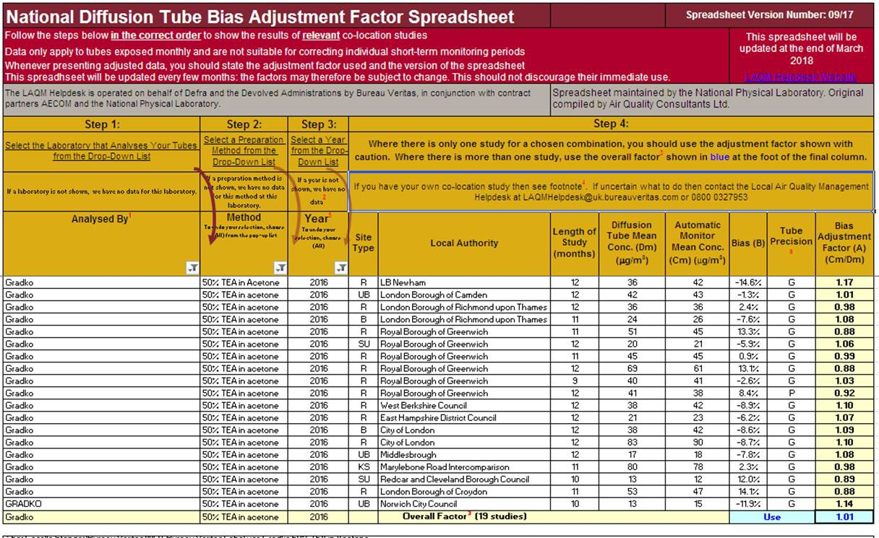

PM₁₀ Monitoring Adjustment
All TEOM data from 2008 onwards has been adjusted using the King’s College London Volatile Correction Method (VCM). This was carried out by Ricardo for the sites affiliated to the Scottish Air Quality Network in 2015 as part of the Scottish Government’s contract.
The PM₁₀ monitor at the Grangemouth AURN site has been a FDMS since April 2009 and so no correction factor has been applied to the data after this date. The VCM has been applied to the 2008 and 2009 AURN TEOM data by King’s College under contract to Defra.
The PM₁₀ monitor at the Banknock 2 site has been a FIDAS since February 2015 so no correction factor has been applied to the data after this date.

Estimating PM_{2.5} from PM₁₀ Measurements
LAQM TG (16) describes two methodologies for estimating PM_{2.5} from PM₁₀ measurements. Method one is to apply a locally derived correction ratio calculated from local sites measuring both PM₁₀ and PM_{2.5}. The second is to apply a nationally derived correction ratio of 0.7. The national correction ratio should only be used where no appropriate local sites measuring both PM₁₀ and PM_{2.5} are available. The locally derived correction ratio should only be used at sites of the same classification.
In 2017, Falkirk Council had three local sites monitoring both PM₁₀ and PM_{2.5} these being the Banknock 2, the Grangemouth AURN and Falkirk West Bridge St sites. The Falkirk West Bridge St automatic station was upgraded to include PM_{2.5} monitoring capabilities through the commissioning of a FIDAS analyser in November 2016. A sufficient volume of monitoring data has been collected since this installation date.
Using guidance in LAQM TG (16) the PM_{2.5}/ PM₁₀ ratios were calculated for the Banknock 2, Grangemouth AURN and Falkirk West Bridge St sites. The ratio derived from the Banknock 2 data was applied to sites classified as roadside (non-urban), the ratio derived from the AURN data was applied to sites classified as urban background/industrial and the ratio derived from the Falkirk West Bridge St data was applied to sites classified as roadside (urban).
The local correction ratios were used to estimate PM_{2.5} from PM₁₀ measurements at the following sites; Falkirk Haggs, Grangemouth Municipal Chambers, Falkirk

Graham’s Road, Banknock 3 and Main St Bainsford. Results are shown in Table
A.12 in Appendix A. Table C.1 displays how the local ratios have been derived.

Table C. 2 – Locally Derived PM_{2.5} / PM₁₀ Correction Ratio

Site | Site Type | Annual Average PM₁₀ (µg/m3), 2017 | Annual Average PM2.5  (µg/m3),  2017 | Ratio
A7 Falkirk West Bridge St | Roadside (Urban) | 10 | 6 | 0.6
A8 AURN | Urban Background /  Industrial | 9 | 6 | 0.67
A13 Banknock 2 | Roadside (Non-urban) | 13 | 9 | 0.46
Short term to long term adjustments
The annual average PM₁₀ concentration for the Banknock 3 site has been annualised. This site achieved a data capture below 75% for PM₁₀ in 2017. Grangemouth Municipal Chambers and Grangemouth AURN were used as background sites to calculate the adjustment ratio following guidance set out in Box
7.9 of the LAQM TG (16). Details are shown in Table C.2.

Table C. 3 – PM₁₀ short term to long term adjustment factor – Banknock 3

Banknock 3 (Urban Background) | Site Type | Annual Mean 2017, µg/m³ | Data capture 2017, % | Period Mean, µg/m³ | Ratio
Banknock 2 | Roadside | 13 | 99 | 11.55 | 1.13
Haggs | Roadside | 12 | 95 | 12.05 | 1
 |  |  |  | Average | 1.06

QA/QC Automatic Monitoring

Table C. 4 – Details of the QA/QC at the automatic monitoring stations in 2017

QA / QC in 2017
Site | Analyser | Network
A3. Bo’ness | SO₂ | SAQN
A4. Falkirk Haggs | NO_{x} | SAQN
A4. Falkirk Haggs | PM10 (TEOM) | SAQN
A5. Falkirk Hope St | NO_{x} | SAQN
A5. Falkirk Hope St | SO₂ | SAQN
A7. Falkirk West Bridge St | NO_{x} | SAQN
A7. Falkirk West Bridge St | PM10, PM2.5 (FIDAS) | SAQN
A8. Grangemouth AURN (Inchyra) | NO_{x} | AURN
A8. Grangemouth AURN (Inchyra) | PM₁₀ (TEOM- FDMS) | AURN
A8. Grangemouth AURN (Inchyra) | PM_{2.5} (TEOM- FDMS) | AURN
A8. Grangemouth AURN (Inchyra) | SO₂ | AURN
A9. Grangemouth Moray | NO_{x} | AURN
A9. Grangemouth Moray | SO₂ | SAQN

A10. Grangemouth Municipal Chambers | NO_{x} | SAQN
A10. Grangemouth Municipal Chambers | PM₁₀ (TEOM) | SAQN
A10. Grangemouth Municipal Chambers | SO₂ | SAQN
A11. Grangemouth Zetland Park | SO2 | SAQN
A12. Falkirk Grahams Rd | PM₁₀ (TEOM) | SAQN
A13. Banknock 2 | PM10, PM2.5 (FIDAS) | SAQN
A14. Banknock 3 | PM₁₀ (Osiris) | Local
A15 Main St Bainsford | NO_{x} | SAQN
A15 Main St Bainsford | PM₁₀ (TEOM) | SAQN

Local sites:
- Data is downloaded at site and a flow check is carried out on a fortnightly basis.
- A filter change is carried out on an approximate four weekly basis, although this is dependent on the weather and filter loading. The filters are retained for analysis.
- As with the other sites all LSO site visits are carried out by Falkirk Council staff who are audited to AURN standards.
- The Osiris is serviced on an annual basis and covered by a service agreement for any breakdowns, both are completed off-site.

AURN and Scottish AQ network sites:
- All NO_{x} and SO₂ analysers receive fortnightly zero and span checks and filter changes
- TEOM heads are cleaned and the filter changed on a four weekly basis or more frequently if the filter loading goes above 90%
- TEOM-FDMS heads are cleaned and filters changed as directed by AURN CMCU (i.e. at 90% loading)
- All LSO site visits are carried out by Falkirk Council staff who are audited to AURN standard
- Analysers are covered by a contract for emergency callout and receive a service every six months
- QA/QC is to AURN / ‘national’ standards
- Falkirk Council also checks the data on its systems and is in communication with Ricardo to ensure the best data quality. Unscaled data is supplied by Falkirk Council to Ricardo for the Scottish AQ Network sites on a six monthly basis to improve data capture

Glossary of Terms

Abbreviation | Description
AQAP | Air Quality Action Plan – A detailed description of measures, outcomes, achievement dates and implementation methods, showing how the LA intends to achieve air quality limit values
AQMA | Air Quality Management Area – An area where air pollutant concentrations exceed / are likely to exceed the relevant air quality objectives. AQMAs are declared for specific pollutants and objectives
APR | Air quality Annual Progress Report
AURN | Automatic Urban and Rural Network (UK air quality monitoring network)
Defra | Department for Environment, Food and Rural Affairs
DMRB | Design Manual for Roads and Bridges – Air quality screening tool produced by Highways England
ECSVEP | East Central Scotland Vehicle Emissions Partnership
Eia | Environmental Impact Assessment
FDMS | Filter Dynamics Measurement System
LAQM | Local Air Quality Management
NAQS | National Air Quality Strategy
NO₂ | Nitrogen Dioxide
NO_{x} | Nitrogen Oxides
PM₁₀ | Airborne particulate matter with an aerodynamic diameter of 10µm (micrometres or microns) or less
PM2.5 | Airborne particulate matter with an aerodynamic diameter of  2.5µm or less
QA/QC | Quality Assurance and Quality Control
Rdf | Refuse Derived Fuel
SO₂ | Sulphur Dioxide
TEOM | Tapered Element Oscillating Microbalance

References
  - Technical Guidance LAQM.TG (16), Defra and Devolved Administrations, February 2018.
  - Civil Aviation Authority, UK Airport Statistics http://www.caa.co.uk/default.aspx?catid=80&pagetype=88&pageid=3& sglid=3#Data
  - Policy Guidance LAQM.PG (S) 16, Defra and Devolved Administrations, March 2016.

